Unit – 3
Unit – 3: Git and Version Control System
1. What is Git?
- Git is a distributed version control system used for tracking source code changes efficiently.
- It helps multiple developers collaborate together without overwriting each other’s project modifications accidentally.
- Git stores project history permanently, allowing developers to restore previous versions whenever required easily.
- It was created by Linus Torvalds mainly for managing Linux kernel development projects efficiently.
- Git supports branching, merging, and offline development, making software development faster and more reliable.

2. List any two features of Git.
- Git provides distributed development support, allowing developers to work independently without constant internet connection.
- Git includes powerful branching features for creating separate development paths without affecting original projects.
- It maintains complete project history, helping developers track every modification made during software development activities.
- Git offers fast performance while handling large repositories and complex collaborative development environments efficiently.
- It supports secure data integrity through unique hashing mechanisms that protect project contents consistently.

3. What are the benefits of using Git?
- Git improves collaboration between developers by allowing simultaneous work on shared software development projects.
- It provides backup and recovery options by storing complete project history in repositories safely.
- Git reduces development conflicts through efficient branching and merging capabilities during project modifications regularly.
- It allows developers to revert mistakes quickly without permanently damaging important project source files.
- Git increases development productivity by automating version tracking and simplifying software management operations effectively.

4. Define Version Control System (VCS).
- A Version Control System is software used for managing changes made to project files.
- It records every modification performed on documents, source code, and development resources systematically over time.
- VCS enables multiple users to collaborate on projects without losing important project information accidentally.
- It helps developers restore previous project versions whenever errors or unexpected problems occur during development.
- Version Control Systems improve project organization, tracking, and software maintenance throughout development lifecycle activities effectively.

5. What is the difference between Git and GitHub?
- Git is a version control tool, whereas GitHub is an online hosting platform for repositories.
- Git works locally on developer systems, while GitHub mainly provides remote repository management services online.
- Git manages source code tracking, whereas GitHub offers collaboration tools like pull requests and issues.
- Git can operate without internet access, but GitHub requires internet connectivity for remote collaboration purposes.
- Git is software installed on computers, while GitHub is a cloud-based repository hosting service platform.

6. What is a repository in Git?
- A repository in Git is a storage location containing project files and version history details.
- It stores commits, branches, configurations, and complete development records related to specific software projects carefully.
- Repositories help developers organize project resources and manage collaborative software development activities efficiently together.
- A repository can exist locally on computers or remotely on platforms like GitHub services online.
- Git repositories maintain all project modifications, allowing developers to restore and compare previous versions easily.

7. What is the Git workflow?
- Git workflow represents the sequence of steps followed during software development using Git repositories effectively.
- Developers first modify files, then stage changes before committing them into the local repository system.
- After committing changes locally, developers push updates into remote repositories for team collaboration purposes.
- Team members pull latest repository changes regularly to maintain updated and synchronized project development environments.
- Git workflow improves development organization, collaboration, and efficient management of software development projects consistently.

8. What is staging in Git?
- Staging in Git is the process of preparing selected file changes before creating commits carefully.
- It allows developers to choose specific modifications instead of committing every project change simultaneously together.
- The staging area acts as an intermediate location between modified files and permanent repository commits safely.
- Developers commonly use the git add command to move files into the staging area successfully.
- Staging improves commit organization by allowing meaningful and structured version tracking during project development activities.

9. What is a commit in Git?
- A commit in Git is a saved snapshot representing specific project changes at particular moments.
- Commits help developers track development progress and identify modifications performed during software development activities clearly.
- Each commit contains unique identification hashes, ensuring secure tracking and integrity of project changes permanently.
- Developers usually include descriptive commit messages explaining the purpose of modifications added into repositories carefully.
- Commits allow project restoration and rollback whenever unexpected issues occur during software development processes frequently.

10. What is the purpose of git init command?
- The git init command initializes a new Git repository inside an existing project directory successfully.
- It creates a hidden .git folder containing repository configuration and version control information automatically generated.
- Developers use git init before starting version tracking activities for newly created software development projects initially.
- The command enables Git features such as commits, branching, staging, and repository management operations effectively afterward.
- Git initialization helps developers organize project changes systematically from the beginning of software development processes properly.

11. What is the use of git clone?
- The git clone command creates a complete copy of an existing remote repository locally instantly.
- It downloads project files, commit history, branches, and repository configurations into developer systems automatically together.
- Developers use git clone when contributing to projects hosted on remote repository platforms like GitHub.
- Cloning simplifies collaboration by allowing developers to access and modify project repositories independently without difficulty.
- The command helps maintain synchronization between local repositories and remote repositories during collaborative development work continuously.

12. What is the difference between local and remote repository?
- A local repository exists on a developer’s personal computer for independent project development activities daily.
- A remote repository is stored on online servers for collaborative access by multiple developers simultaneously together.
- Local repositories allow offline development, while remote repositories usually require internet connectivity for synchronization purposes.
- Developers commit changes locally first before pushing updates into remote repositories for team collaboration effectively.
- Remote repositories provide centralized backup and sharing facilities, improving collaborative software development project management significantly.

13. What are the different file states in Git?
- Git files can exist in modified, staged, committed, and untracked states during development processes regularly.
- Modified files contain unsaved changes that have not yet been prepared for repository commits properly.
- Staged files are prepared changes waiting to become permanent commits inside repository history successfully afterward.
- Committed files represent permanently stored snapshots already saved into Git repository version history completely and securely.
- Untracked files are new project files not yet added into Git version tracking mechanisms initially.

14. What is the purpose of git status?
- The git status command displays current repository conditions and file tracking information clearly for developers.
- It shows modified, staged, committed, and untracked files present within the project repository environment currently active.
- Developers use git status before commits to verify selected changes and avoid committing unwanted modifications accidentally.
- The command helps monitor repository synchronization between local development environments and remote repositories effectively together.
- Git status improves project management by providing accurate repository progress and version tracking information continuously available.

15. What is the role of .git directory?
- The .git directory stores all repository metadata and version control information related to project development.
- It contains commit history, branches, configuration settings, and repository tracking data maintained by Git internally.
- Developers should avoid modifying .git directory contents manually because improper changes may damage repositories permanently.
- The directory enables Git commands to function correctly while managing project versions and repository operations efficiently.
- Hidden .git folders are automatically created whenever developers initialize repositories using git init command successfully.

16. Explain Git and its key features in detail.

Introduction to Git

Point 1
Git is a distributed version control system designed for tracking software development project modifications efficiently.

Point 2
It helps developers manage source code changes systematically throughout the entire software development lifecycle process.

Point 3
Git allows multiple developers to collaborate simultaneously without overwriting important project files accidentally during development.

Distributed Version Control

Point 1
Git stores complete repository copies on every developer system, improving backup and reliability significantly.

Point 2
Developers can work offline without depending continuously on remote servers or internet connectivity availability.

Point 3
Distributed architecture increases development flexibility and reduces dependency on centralized repository management systems effectively.

Branching Feature

Point 1
Git provides powerful branching support for creating independent development environments within the same repository structure.

Point 2
Developers can experiment with new features safely without affecting the stable project source code directly.

Point 3
Branching improves project organization and simplifies parallel software development activities among multiple development teams effectively.

Merging Capability

Point 1
Git supports merging branches together after successful completion of development tasks and testing procedures carefully.

Point 2
The merging process combines source code modifications from different developers into a unified repository version safely.

Point 3
Git automatically identifies conflicts and assists developers in resolving them before final project integration processes.

Commit and History Tracking

Point 1
Git records every project modification permanently using commits with unique identification hashes for tracking purposes.

Point 2
Developers can review project history and restore previous repository versions whenever unexpected problems occur frequently.

Point 3
Commit messages help maintain detailed documentation explaining software modifications and development progress clearly over time.

Security and Data Integrity

Point 1
Git uses SHA hashing algorithms for protecting repository contents against accidental corruption and unauthorized modifications effectively.

Point 2
Every commit receives a unique identifier ensuring secure tracking of software development activities consistently throughout projects.

Point 3
The integrity mechanism ensures repository data remains accurate and trustworthy during collaborative development operations continuously.

Collaboration Features

Point 1
Git simplifies collaboration among developers working together on large software development projects across different locations.

Point 2
Remote repositories enable developers to share code modifications and synchronize project updates efficiently with team members.

Point 3
Git improves team productivity by simplifying code sharing, reviewing, and collaborative software development workflows significantly.

Advantages of Git

Point 1
Git improves development efficiency by automating source code tracking and repository management operations consistently throughout projects.

Point 2
It reduces project risks by providing rollback mechanisms for recovering previous stable software versions successfully.

Point 3
Git has become an industry-standard version control system widely adopted across professional software development environments globally.

Git Features Flowchart
+------------------+
| Git |
+------------------+
|
-------------------------------------
| | | |
Branching Merging Commits Collaboration
| | | |
Parallel Combine History Team Development
Development Changes Tracking and Synchronization

17. Discuss the benefits of using Git in software development projects.

Improved Collaboration

Point 1
Git enables multiple developers to work together efficiently without overwriting each other’s project modifications accidentally.

Point 2
Team members can contribute independently while maintaining synchronization with shared remote repository environments continuously.

Point 3
Collaboration features simplify communication and coordination among geographically distributed software development teams effectively.

Better Version Tracking

Point 1
Git maintains complete project history records containing all modifications performed during software development processes systematically.

Point 2
Developers can compare previous repository versions and analyze changes introduced into software applications carefully.

Point 3
Version tracking improves software maintenance and helps identify development issues during debugging and testing activities efficiently.

Safe Backup and Recovery

Point 1
Git repositories store multiple project versions, providing reliable backup mechanisms for important development resources securely.

Point 2
Developers can restore deleted or corrupted files easily using previous repository snapshots maintained within Git history.

Point 3
Backup functionality reduces risks associated with accidental project file modifications or unexpected system failures effectively.

Efficient Branching System

Point 1
Git branching allows developers to create isolated environments for testing new software features independently safely.

Point 2
Different development tasks can proceed simultaneously without affecting stable application source code directly during development.

Point 3
Branching improves project flexibility and supports agile software development methodologies efficiently across collaborative environments.

Faster Development Process

Point 1
Git automates repository management operations, reducing manual effort required for tracking project modifications consistently.

Point 2
Fast repository operations improve software development productivity and minimize delays during collaborative coding activities significantly.

Point 3
Developers spend less time managing files and more time implementing application functionalities effectively throughout projects.

Improved Code Quality

Point 1
Git supports code review practices by allowing developers to examine modifications before repository integration carefully.

Point 2
Review mechanisms help identify coding errors, security issues, and software bugs during development processes efficiently.

Point 3
Maintaining version history improves software quality assurance and ensures stable application releases consistently over time.

Remote Repository Support

Point 1
Remote repositories allow centralized project storage accessible by developers from different locations worldwide conveniently.

Point 2
Developers can push updates, pull modifications, and synchronize project files through online repository platforms efficiently.

Point 3
Remote collaboration improves project accessibility and simplifies distributed software development management significantly for organizations.

Industry Standard Adoption
- Git is widely used across professional software industries due to its reliability and advanced repository features.
- Knowledge of Git improves career opportunities for software developers working in modern development environments globally.
- Most software companies integrate Git into their development workflows for efficient project management and collaboration.

Benefits of Git Diagram
+----------------+
| Benefits |
+----------------+
---------------------------------
| | | |
Collaboration Backup Branching Tracking
| | | |
Teamwork Recovery Parallel Version History

18. Explain the Git workflow with a neat diagram.
Introduction to Git Workflow
- Git workflow represents the sequence of development activities followed while managing software projects using Git repositories.
- It helps developers organize coding, testing, staging, committing, and synchronization processes systematically during project development.
- Git workflow improves collaboration and ensures efficient management of software development tasks among multiple developers.

Creating or Cloning Repository
- Developers begin by creating a new repository or cloning an existing remote repository into local systems.
- The git init command creates a fresh repository, while git clone copies existing repository contents locally.
- Repository creation provides the foundation for tracking software modifications and maintaining complete development history records.

Modifying Project Files
- Developers edit source code files and perform required software development changes inside the working directory environment.
- Modified files remain in an unstaged condition until developers prepare them for repository commit operations carefully.
- Git continuously tracks file modifications and identifies updated project resources during development activities efficiently.

Staging Changes
- Developers use the git add command to move selected project modifications into the staging area successfully.
- The staging area acts as an intermediate space between modified files and permanent repository commit operations.
- Staging allows developers to organize meaningful commits by selecting only necessary project modifications carefully.

Committing Changes
- Developers create commits using the git commit command after verifying staged project modifications properly.
- Each commit stores a permanent snapshot representing project conditions at specific development stages securely.
- Commit messages explain software modifications clearly, improving project documentation and development tracking significantly.
Working with Branches
- Developers create branches for implementing new features without affecting stable project source code directly.
- Branching enables parallel development activities among multiple developers working on separate project functionalities independently.
- Git branches simplify experimentation, testing, and collaborative development operations during software project implementation processes effectively.

Synchronizing with Remote Repository
- Developers push local repository commits into remote repositories using the git push command regularly.
- Team members pull latest repository updates using the git pull command for maintaining synchronized development environments.
- Remote synchronization improves collaboration and ensures every developer accesses updated project resources continuously.

Merging and Final Integration
- Completed development branches are merged into the main branch after successful testing and code verification processes.
- Git automatically combines compatible modifications while identifying conflicts requiring manual developer intervention carefully.
- Final integration ensures stable software releases and maintains organized repository management throughout development lifecycle activities.
Git Workflow Diagram
+-------------------+
| Working Directory |
+-------------------+
|
git add
|
+-------------------+
| Staging Area |
+-------------------+
|
git commit
|
+-------------------+
| Local Repository |
+-------------------+
|
git push
|
+-------------------+
| Remote Repository |
+-------------------+
|
git pull
|
+-------------------+
| Developer System |
+-------------------+

19. Compare Git and GitHub with suitable examples.
Introduction to Git and GitHub
- Git is a distributed version control system used for tracking software development project modifications efficiently.
- GitHub is an online platform used for hosting and managing Git repositories collaboratively.
- Both technologies work together for software development but perform different functions within development environments effectively
Purpose and Functionality
- Git manages version tracking, branching, commits, and repository operations directly on developer systems locally.
- GitHub provides cloud-based repository hosting services and collaborative development tools for software project management online.
- Git focuses mainly on source code tracking, whereas GitHub focuses on collaboration and repository sharing functionalities.
Working Environment
- Git operates locally on developer computers and supports offline software development without internet connectivity continuously.
- GitHub requires internet access because repositories are stored and managed through cloud-based online servers remotely.
- Developers can continue coding locally using Git even when remote GitHub services become temporarily unavailable.
Collaboration Features
- Git allows developers to manage repository versions independently without requiring online collaborative development environments continuously.
- GitHub provides pull requests, issue tracking, discussions, and collaborative review mechanisms for development teams effectively.
- Collaboration becomes easier using GitHub because developers can share repositories and review modifications conveniently online.
Repository Storage
- Git repositories can exist entirely on local systems without requiring external hosting services for development activities.
- GitHub stores repositories remotely, providing centralized access for developers located across different geographical regions worldwide.
- Remote repository storage improves project accessibility and ensures reliable backup of software development resources consistently.
Commands and Operations
- Git commands include git init, git add, git commit, git branch, and git merge for repository management.
- GitHub operations commonly involve repository hosting, pull request creation, issue management, and collaborative code reviews online.
- Developers frequently combine Git local commands with GitHub remote repository synchronization processes during project development.
Suitable Example
- A developer uses Git locally for tracking modifications while creating a Java application on personal computers independently.
- The same developer uploads the repository into GitHub for collaborative access by project team members online remotely.
- Team members review source code through GitHub while continuing local development operations using Git repositories effectively.
Advantages Comparison
- Git improves software development efficiency through fast repository operations and advanced version tracking mechanisms consistently.
- GitHub improves collaborative development by providing centralized project management and online repository accessibility features effectively.
- Together, Git and GitHub create a powerful environment supporting modern collaborative software development workflows successfully.
Git vs GitHub Comparison Diagram
+-------------+ +--------------+
| Git | | GitHub |
+-------------+ +--------------+
| Local VCS | | Cloud Hosting|
| Offline Use | | Collaboration|
| Versioning | | Pull Requests|
| Branching | | Repository UI|
+-------------+ +--------------+
20. Describe the steps to install Git on Windows and Linux systems.
Introduction to Git Installation
- Git installation is the process of setting up the Git version control system on computer systems successfully.
- Developers install Git before managing repositories, tracking project modifications, and performing collaborative development activities effectively.
- Git supports multiple operating systems including Windows, Linux, and macOS for flexible software development environments.

Installing Git on Windows
- Developers first visit the official Git website and download the Windows installation package carefully.
- The downloaded installer file contains required setup components and configuration options for Windows operating systems.
- Windows installation packages are available for both 32-bit and 64-bit computer architectures depending on system requirements.

Running Windows Installer
- Users execute the downloaded setup file and follow installation wizard instructions displayed on computer screens carefully.
- The installer allows selection of destination folders, editor preferences, and command-line integration settings during installation processes.
- Developers generally keep default installation options because they provide suitable configurations for most software development activities.

Completing Windows Installation
- The installation wizard copies Git files into the selected system directory and configures required environment variables automatically.
- After successful installation, developers can access Git commands through Git Bash and Windows command prompt environments.
- Verification is performed using the git --version command to confirm successful Git installation on Windows systems properly.

Installing Git on Linux
- Linux users install Git through package management systems available within their Linux distribution environments conveniently.
- Debian or Ubuntu users commonly use the sudo apt install git command for installing Git packages successfully.
- Fedora or CentOS users generally use sudo dnf install git or related package management commands appropriately.

Updating Linux Packages
- Developers update package repositories before installation using commands like sudo apt update for improved package compatibility.
- Updating repositories ensures latest Git versions and security updates become available during installation procedures successfully.
- Package updates reduce installation problems caused by outdated Linux software repositories or missing dependencies effectively.

Verifying Git Installation
- Developers check successful installation using the git --version command within terminal or command prompt environments easily.
- The command displays installed Git version details, confirming proper installation and configuration completion successfully.
- Verification ensures Git commands become accessible for repository management and software development activities consistently.

Importance of Git Installation
- Git installation provides developers with powerful tools for managing source code and collaborative software projects efficiently.
- Proper installation ensures stable repository operations and improves productivity during software development lifecycle activities consistently.
- Installing Git correctly forms the foundation for learning advanced version control concepts and collaborative development workflows.

Git Installation Flowchart
+-------------------+
| Download Git |
+-------------------+
|
+-------------------+
| Run Installer |
+-------------------+
|
+-------------------+
| Configure Options |
+-------------------+
|
+-------------------+
| Complete Setup |
+-------------------+
|
+-------------------+
| Verify Installation|
+-------------------+

21. Explain how to configure Git environment after installation.
Introduction to Git Configuration
- Git configuration customizes the development environment according to developer preferences and project requirements efficiently.
- Developers configure usernames, email addresses, editors, and repository settings immediately after successful Git installation procedures.
- Proper configuration ensures commits contain accurate author information and repository operations function correctly during development.

Configuring Username
- Developers configure usernames using the git config --global user.name "Username" command within terminal environments successfully.
- Usernames identify developers responsible for specific project modifications stored inside repository commit history records permanently.
- Correct username configuration improves collaboration and helps maintain accurate software development documentation throughout projects consistently.

Configuring Email Address
- Developers configure email addresses using the git config --global user.email "email@example.com" command carefully after installation.
- Email addresses become associated with commits and help identify contributors during collaborative repository development activities efficiently.
- Proper email configuration ensures synchronization with remote repository platforms like GitHub during development workflows effectively.

Setting Default Editor
- Git allows developers to configure preferred text editors for commit messages and repository operations conveniently afterward.
- Developers commonly configure editors like Visual Studio Code, Vim, or Nano according to personal preferences successfully.
- Editor configuration improves usability and simplifies commit message editing during software development activities consistently.

Checking Git Configuration
- Developers verify configuration settings using the git config --list command within terminal or command prompt environments easily.
- The command displays usernames, email addresses, editor preferences, and repository settings configured within Git environments properly.
- Verification ensures configuration accuracy and prevents issues during repository operations or collaborative software development processes.

Configuring Default Branch Name
- Developers can configure default branch names using commands like git config --global init.defaultBranch main successfully.
- Modern development workflows commonly use main instead of master as the primary repository branch name consistently.
- Default branch configuration improves repository standardization across collaborative software development environments effectively.

Configuring Credential Storage
- Git supports credential storage mechanisms for securely remembering authentication details used during remote repository operations regularly.
- Developers configure credential helpers for reducing repeated password entry requirements during GitHub repository synchronization activities.
- Secure credential management improves convenience and strengthens authentication practices within collaborative development workflows consistently.

Importance of Git Environment Configuration
- Proper Git configuration improves repository management efficiency and ensures smooth software development operations consistently afterward.
- Configured environments reduce errors related to author identification, repository synchronization, and collaborative development processes significantly.
- Git configuration establishes reliable development environments supporting efficient version control and project collaboration activities successfully.

Git Configuration Diagram
+--------------------+
| Install Git |
+--------------------+
|
+--------------------+
| Configure Username |
+--------------------+
|
+--------------------+
| Configure Email |
+--------------------+
|
+--------------------+
| Set Default Editor |
+--------------------+
|
+--------------------+
| Verify Settings |
+--------------------+
24. Discuss the working of remote repositories and commands used to manage them.
Introduction to Remote Repositories
- Remote repositories are online storage locations used for sharing and synchronizing Git project repositories collaboratively.
- Developers use remote repositories for centralized project management and collaborative software development activities efficiently.
- Platforms like GitHub provide remote repository hosting and collaborative development features successfully.

Working of Remote Repositories
- Remote repositories store project files, commit history, and branches on cloud-based online servers securely.
- Developers synchronize local repositories with remote repositories for sharing software modifications among development teams effectively.
- Remote repositories improve project accessibility and support collaborative software development from different geographical locations conveniently.

Adding Remote Repository
- Developers use the git remote add origin repository_URL command for connecting local repositories with remote repositories.
- The command establishes communication between local development environments and remote repository hosting platforms successfully.
- Adding remote repositories enables synchronization of commits, branches, and project resources across development systems efficiently.

Pushing Changes to Remote Repository
- Developers use the git push origin main command for uploading local repository commits into remote repositories.
- Push operations synchronize project modifications and make updated source code available to other team members immediately.
- Regular pushing improves collaboration and maintains updated repository versions throughout software development lifecycle activities consistently.

Pulling Changes from Remote Repository
- Developers use the git pull origin main command for downloading latest repository changes from remote servers successfully.
- Pull operations combine fetching and merging functionalities for maintaining synchronized local development environments consistently.
- Developers pull repository updates frequently to avoid conflicts and maintain updated project resources during collaborative development.

Fetching Repository Updates
- Developers use the git fetch command for retrieving remote repository changes without automatically merging modifications locally.
- Fetch operations allow developers to review remote changes before integrating them into local repositories carefully afterward.
- Fetching improves repository management and helps developers analyze collaborative project modifications systematically during development processes.

Viewing Remote Repository Information
- Developers use the git remote -v command for displaying connected remote repository details and URLs clearly.
- The command helps verify repository connections and ensures proper synchronization settings during collaborative development operations successfully.
- Viewing repository information improves remote repository management and reduces configuration-related development issues significantly.

Importance of Remote Repositories
- Remote repositories improve collaboration, backup, accessibility, and synchronization within software development environments effectively.
- They allow developers to share project modifications securely while maintaining centralized repository management consistently throughout projects.
- Remote repository systems form an essential component of modern collaborative software development workflows successfully.

Remote Repository Flowchart

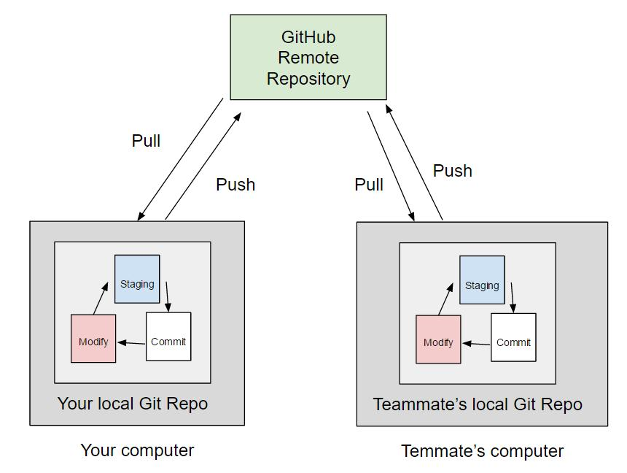

25. Explain the Git repository structure and the role of the .git folder.
Introduction to Git Repository Structure
- Git repositories contain project files along with hidden metadata required for version control operations consistently afterward.
- Repository structures help developers organize project resources and maintain software development history systematically over time.
- The .git folder acts as the core component responsible for repository management and version tracking activities effectively.
Working Directory
- The working directory contains actual project source code files currently modified by developers during software development processes.
- Developers perform editing, testing, and implementation tasks directly inside the working directory environment regularly afterward.
- Modified project files remain visible inside the working directory until committed into repository history successfully.
Staging Area
- The staging area temporarily stores selected project modifications before permanent repository commit operations occur successfully.
- Developers use the git add command for moving files from working directory into staging environments carefully.
- Staging improves commit organization and allows developers to prepare meaningful repository snapshots efficiently during development.
Local Repository
- The local repository stores commits, branches, and project version history on developer systems securely afterward.
- Developers manage local repositories independently without requiring continuous internet connectivity during software development activities efficiently.
- Local repositories improve flexibility and provide backup mechanisms for software project resources consistently throughout development.
Role of the .git Folder
- The .git folder stores all metadata and internal information required for Git repository management operations effectively.
- It contains commits, branches, configuration files, logs, and repository tracking information maintained automatically by Git systems.
- Developers should avoid modifying .git folder contents manually because improper changes may corrupt repositories permanently.
Important Files inside .git Folder
- The .git/config file stores repository-specific configuration settings related to remotes and development environments carefully.
- The .git/HEAD file identifies the currently active branch within the repository management system consistently afterward.
- The .git/objects folder stores compressed repository objects including commits, trees, and source code modifications securely.
Repository Branch Structure
- Git repositories maintain branches for supporting parallel software development and isolated feature implementation processes effectively.
- Branch structures allow developers to test functionalities independently without affecting stable repository source code directly.
- Branch management improves collaborative software development and simplifies repository organization across development teams successfully.
Importance of Repository Structure
- Repository structure improves project organization, version tracking, and collaborative development workflow management significantly afterward.
- Proper understanding of .git folder roles helps developers manage repositories safely and efficiently throughout software development.
- Git repository structures provide reliable environments for maintaining project history and software modifications consistently over time.
Git Repository Structure Diagram

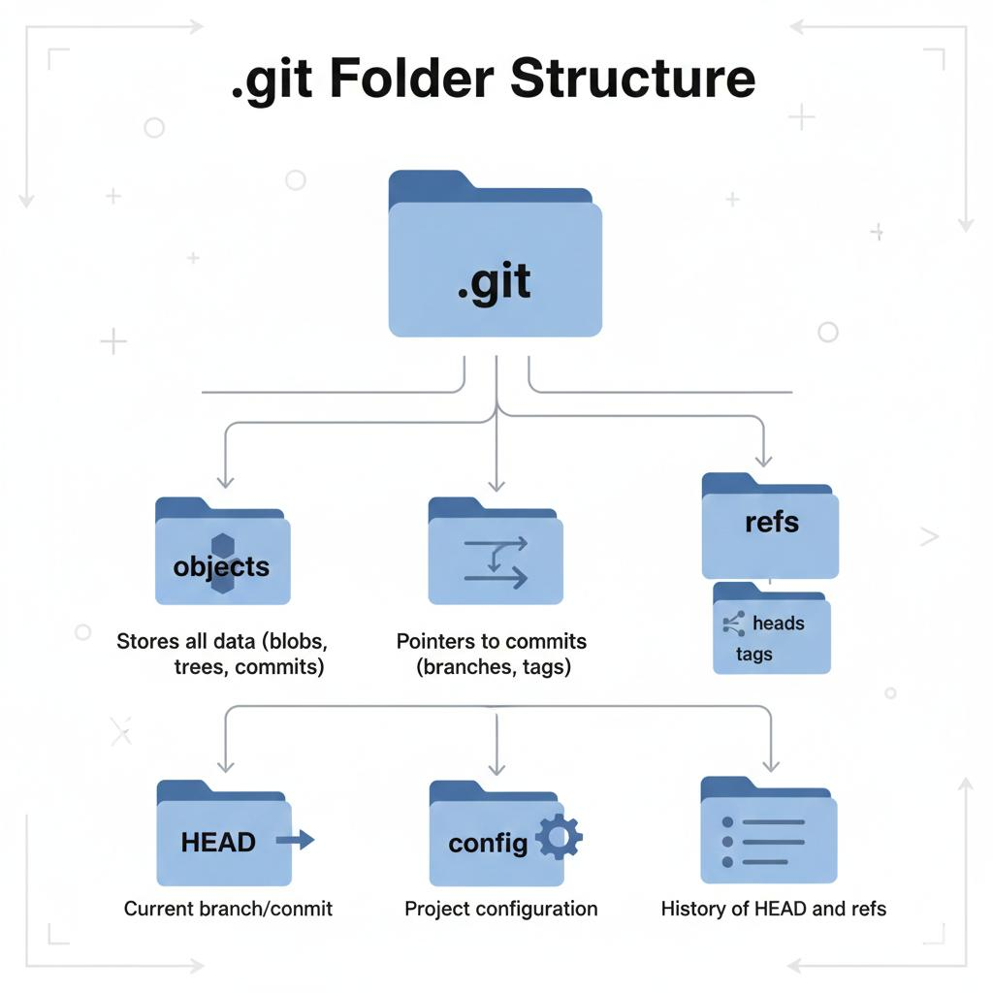
26. Describe the Git file status lifecycle with examples.
Introduction to Git File Lifecycle
- Git file lifecycle represents different states through which files move during software development operations systematically afterward.
- File lifecycle management helps developers track modifications and organize repository operations efficiently within development environments.
- Understanding file states improves repository management and reduces confusion during collaborative software development activities significantly.

Untracked State
- Untracked files are new project files not yet added into Git version tracking mechanisms successfully afterward.
- Git identifies untracked files after creation but before execution of the git add command within repositories.
- Example: Creating a new index.html file initially places it inside the untracked file state automatically.

Tracked State
- Tracked files are files already added into repository tracking systems and monitored continuously by Git successfully afterward.
- Git observes modifications made to tracked files and displays updated statuses during repository operations consistently afterward.
- Example: Files previously committed into repository history remain tracked during future development modifications continuously.

Modified State
- Modified files contain unsaved changes performed after the last repository commit operation completed successfully beforehand.
- Developers edit tracked files, causing Git to recognize modifications within the working directory environment automatically afterward.
- Example: Editing contents of app.java changes the file status from tracked to modified immediately.

Staged State
- Staged files are prepared modifications waiting for permanent repository commit operations to occur successfully afterward.
- Developers move files into staging areas using the git add filename command carefully during repository management activities.
- Example: Executing git add app.java stages modified Java source code for commit operations successfully.

Committed State
- Committed files represent permanently stored snapshots maintained inside repository version history systems securely afterward.
- Developers create commits using the git commit command after verifying staged modifications properly beforehand.
- Example: Running git commit -m "Updated application logic" permanently saves repository modifications successfully.

File Lifecycle Transition
- Files continuously move between untracked, modified, staged, and committed states during software development operations consistently afterward.
- Git status commands display current lifecycle conditions helping developers manage repository modifications systematically during development processes.
- Proper understanding of lifecycle transitions improves repository organization and reduces development errors significantly afterward.

Importance of File Lifecycle
- File lifecycle management improves version tracking, commit organization, and collaborative software project development consistently afterward.
- Developers can identify repository conditions quickly using lifecycle states displayed through Git management commands efficiently.
- Understanding lifecycle processes forms an essential foundation for learning advanced Git repository management concepts successfully.

Git File Status Lifecycle Diagram

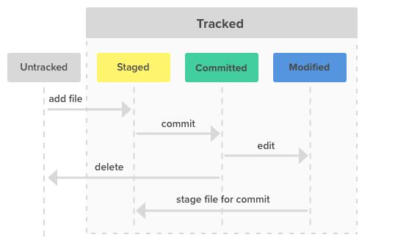
27. Explain staging, unstaging, and committing in Git with commands.
Introduction to Git Operations
- Staging, unstaging, and committing are important Git operations used during repository management and software development workflows.
- These operations help developers organize project modifications before permanently saving them into repository version history systems.
- Understanding these concepts improves repository control and ensures structured software development activities throughout collaborative projects effectively.

Staging in Git
- Staging is the process of preparing selected project modifications before performing repository commit operations successfully afterward.
- Developers use the git add command for moving modified files into the staging area environment carefully.
- Example command: git add index.html stages the specified file for future commit operations successfully.

Purpose of Staging Area
- The staging area acts as an intermediate location between modified files and permanent repository commit snapshots effectively afterward.
- Developers can selectively choose modifications instead of committing every project change simultaneously during development operations consistently.
- Staging improves commit organization and creates meaningful repository history records for software development projects efficiently.

Unstaging in Git
- Unstaging removes files from the staging area without deleting modifications from the working directory environment successfully afterward.
- Developers use the git restore --staged filename command for removing staged files carefully from staging environments.
- Example command: git restore --staged app.java unstages the selected Java source code file successfully.

Purpose of Unstaging
- Unstaging helps developers correct mistakes caused by accidentally staging unnecessary project modifications during development processes effectively.
- Developers can reorganize commits properly before saving repository snapshots permanently into version history systems consistently afterward.
- Unstaging improves repository management flexibility and reduces incorrect commit creation during collaborative development activities significantly.

Committing in Git
- Committing permanently saves staged modifications inside repository history as snapshots representing specific development stages securely afterward.
- Developers use the git commit -m "message" command for creating repository commits with descriptive messages efficiently.
- Example command: git commit -m "Added login functionality" stores modifications permanently within repository history successfully.

Importance of Commit Messages
- Commit messages describe software modifications clearly and improve understanding of repository development history consistently afterward.
- Meaningful messages help developers track implemented features, bug fixes, and software updates during collaborative projects efficiently.
- Proper documentation through commit messages improves project maintenance and repository analysis activities significantly afterward.

Workflow of Staging, Unstaging, and Committing
- Developers first modify files, stage selected modifications, and finally commit changes into repository history systematically afterward.
- Unstaging operations occur whenever developers need to remove incorrectly staged files before commit creation procedures successfully.
- This workflow ensures organized repository management and improves software development efficiency throughout collaborative projects consistently.
Staging and Committing Workflow Diagram

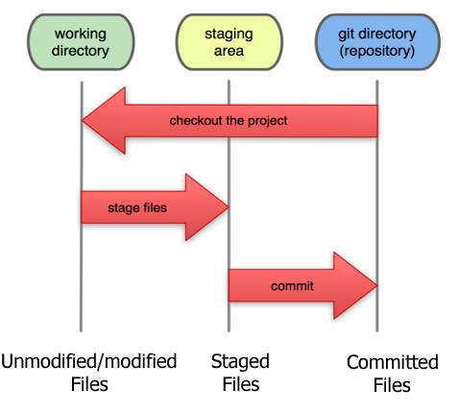

28. Demonstrate how to work with local and remote repositories step by step.
Introduction to Local and Remote Repositories
- Local repositories exist on developer systems, while remote repositories are hosted on online repository platforms securely afterward.
- Developers use both repository types together for collaborative software development and centralized project management effectively.
- Understanding repository synchronization improves teamwork and ensures updated project resources remain accessible consistently afterward.

Creating Local Repository
- Developers create local repositories using the git init command inside project directories successfully afterward.
- The command initializes Git version tracking and creates hidden repository metadata structures within development environments effectively.
- Example command: git init creates a new local repository for project management operations successfully.
Adding Project Files
- Developers create or copy project files into repository working directories before tracking modifications using Git commands consistently.
- New files initially remain untracked until developers add them into version control management systems carefully afterward.
- Example command: git add . stages all project files for repository commit operations successfully.
Creating First Commit
- Developers create commits using the git commit -m "message" command after staging project modifications properly afterward.
- Commits store project snapshots and maintain software development history within local repository environments securely afterward.
- Example command: git commit -m "Initial project setup" creates the repository’s first commit successfully.
Connecting Remote Repository
- Developers connect local repositories with remote repositories using the git remote add origin URL command successfully.
- Remote connections establish communication between local development systems and online repository hosting platforms efficiently afterward.
- Example command: git remote add origin https://github.com/user/project.git connects repositories successfully.
Pushing Local Changes
- Developers upload local repository commits into remote repositories using the git push origin main command regularly afterward.
- Push operations synchronize project modifications and make updates accessible to collaborative development team members efficiently.
- Remote synchronization ensures centralized repository management throughout software development lifecycle activities consistently afterward.
Pulling Remote Changes
- Developers retrieve latest remote repository updates using the git pull origin main command successfully afterward.
- Pull operations download and merge remote modifications into local repositories for maintaining synchronized development environments effectively.
- Frequent pulling reduces repository conflicts and improves collaborative software development management significantly afterward.
Importance of Repository Synchronization
- Working with local and remote repositories improves collaboration, backup management, and software project accessibility consistently afterward.
- Repository synchronization ensures developers access updated source code and maintain consistent project development environments efficiently.
- Understanding synchronization workflows forms an essential requirement for modern collaborative software development successfully.
Local and Remote Repository Workflow Diagram
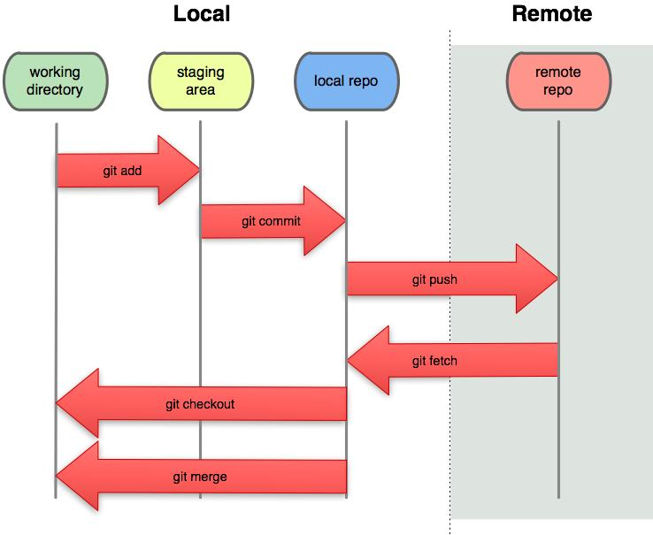
29. Explain the difference between git add, git commit, and git push.
Introduction to Git Commands
- Git provides different commands for managing repository modifications during software development workflows systematically afterward.
- git add, git commit, and git push perform separate functions within Git repository management environments effectively.
- Understanding command differences improves repository organization and collaborative software development operations significantly afterward.

Understanding git add
- The git add command moves modified or new project files into the staging area successfully afterward.
- Staging prepares selected modifications for future repository commit operations during software development activities consistently afterward.
- Example command: git add index.html stages the specified file for commit creation procedures successfully.

Purpose of git add
- Developers use git add for selecting specific modifications instead of committing all repository changes simultaneously afterward.
- The command improves commit organization and helps maintain meaningful repository history records consistently throughout projects effectively.
- git add only stages modifications and does not permanently save changes within repository history systems afterward.

Understanding git commit
- The git commit command permanently stores staged modifications inside repository version history systems securely afterward.
- Commits create snapshots representing project conditions at specific software development stages consistently afterward.
- Example command: git commit -m "Updated homepage design" creates a permanent repository snapshot successfully.

Purpose of git commit
- Commit operations preserve project history and allow developers to restore previous repository versions whenever necessary afterward.
- Developers include descriptive messages explaining software modifications for improving project documentation and maintenance activities significantly afterward.
- git commit saves modifications locally and does not automatically synchronize changes with remote repositories afterward.

Understanding git push
- The git push command uploads local repository commits into connected remote repositories successfully afterward.
- Push operations synchronize project modifications and make repository updates available to collaborative development teams consistently afterward.
- Example command: git push origin main uploads commits into the remote main branch successfully.

Purpose of git push
- Developers use git push for sharing repository modifications and maintaining updated remote project environments consistently afterward.
- Push operations improve collaboration and ensure centralized repository management during software development workflows effectively afterward.
- Without pushing, local repository commits remain inaccessible to other developers using remote repositories collaboratively afterward.

Difference Summary
- git add stages modifications, git commit saves changes locally, and git push uploads modifications remotely afterward.
- These commands work sequentially for maintaining organized repository management and collaborative software development workflows consistently afterward.
- Understanding their differences forms a fundamental requirement for learning Git version control system operations successfully.

git add vs git commit vs git push Diagram
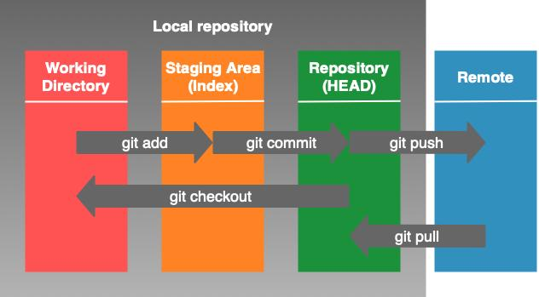
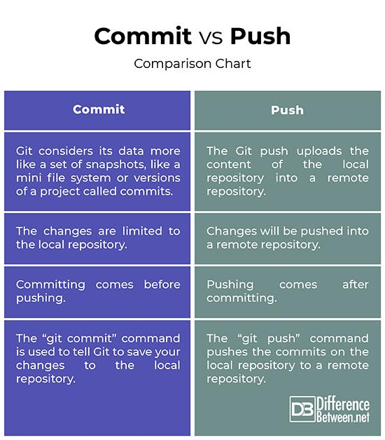

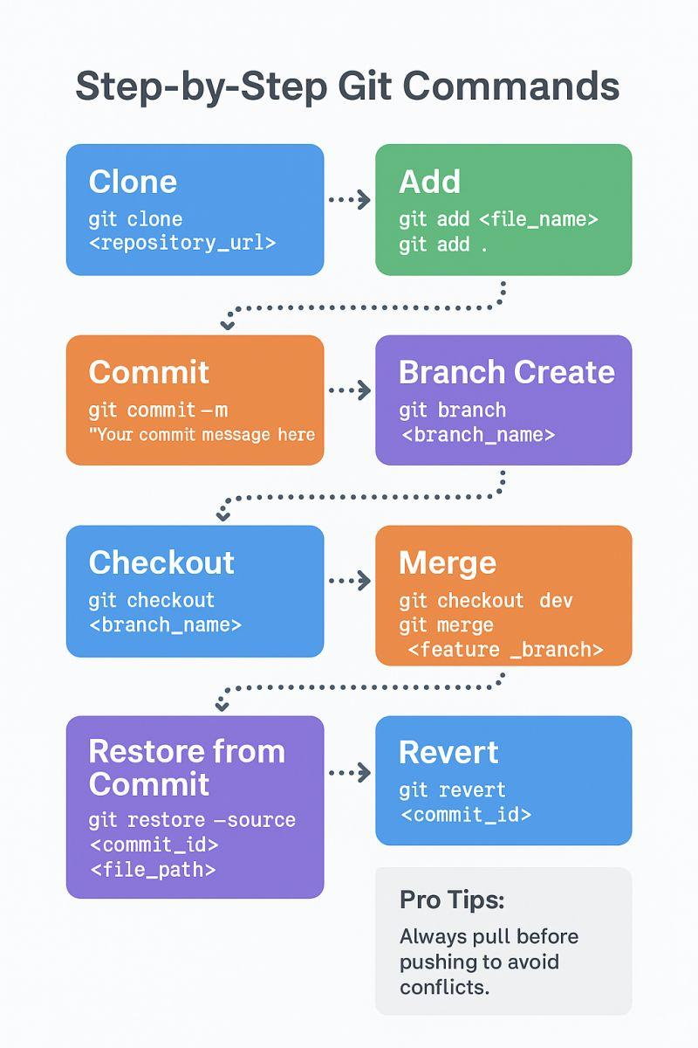
30. Describe the process of cloning, pulling, and pushing changes in Git.
Introduction to Repository Synchronization
- Cloning, pulling, and pushing are important Git operations used for repository synchronization during collaborative development workflows.
- These operations help developers share modifications and maintain updated project resources across distributed development environments effectively.
- Understanding synchronization commands improves teamwork and repository management during software development projects significantly afterward.

Cloning a Repository
- Cloning creates a complete local copy of an existing remote repository including branches and commit history successfully afterward.
- Developers use the git clone repository_URL command for downloading repositories into local development systems efficiently.
- Example command: git clone https://github.com/user/project.git creates a local repository copy successfully.
Purpose of Cloning
- Cloning allows developers to access existing software projects and contribute modifications within collaborative development environments effectively.
- Cloned repositories include all project history required for repository tracking and version control management consistently afterward.
- Developers commonly clone repositories before beginning collaborative software development activities on shared projects successfully.
Pulling Repository Changes
- Pulling retrieves latest project modifications from remote repositories and merges them into local repositories successfully afterward.
- Developers use the git pull origin main command for maintaining synchronized repository environments during collaboration effectively.
- Pull operations reduce repository conflicts and ensure developers work with updated project resources consistently afterward.
Purpose of Pulling
- Pulling improves repository synchronization and helps developers access modifications uploaded by other team members efficiently afterward.
- Regular pull operations reduce development inconsistencies and maintain stable collaborative software development environments successfully.
- Developers commonly pull updates before beginning new development tasks within shared repositories afterward.
Pushing Repository Changes
- Pushing uploads local repository commits into remote repositories for collaborative access by development team members successfully afterward.
- Developers use the git push origin main command for synchronizing local modifications with remote repository servers consistently afterward.
- Push operations ensure centralized repository updates and improve collaborative software development workflows effectively afterward.
Purpose of Pushing
- Pushing allows developers to share implemented features, bug fixes, and software modifications with collaborative teams efficiently afterward.
- Remote repository synchronization improves project accessibility and maintains updated development resources consistently throughout projects afterward.
- Developers usually push commits after successful testing and verification of software modifications carefully afterward.
Complete Synchronization Workflow
- Developers first clone repositories, pull latest updates regularly, and finally push completed modifications successfully afterward.
- This synchronization workflow improves repository consistency and supports collaborative software development operations efficiently afterward.
- Understanding cloning, pulling, and pushing forms an essential foundation for professional Git repository management successfully.
Cloning, Pulling, and Pushing Workflow Diagram
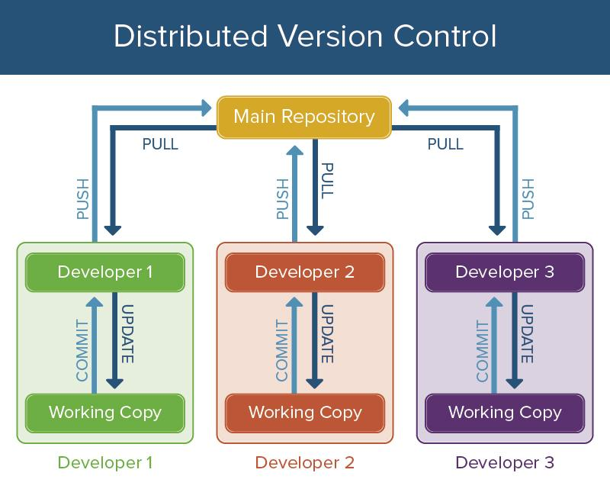
1. What is Docker?
- Docker is an open-source platform used for developing, packaging, and deploying applications inside lightweight containers efficiently.
- It enables developers to bundle application code along with dependencies, libraries, and configurations into a single portable unit.
- Docker ensures consistent execution of applications across different environments such as development, testing, and production systems.
- It simplifies software deployment by eliminating environment-related issues commonly faced during application execution processes.
- Docker is widely used in modern DevOps practices for continuous integration and continuous deployment workflows efficiently.

2. Define Docker Lifecycle.
- Docker lifecycle represents the complete process from creating images to running, managing, and deleting containers systematically.
- It begins with writing a Dockerfile to define application environment and dependencies required for execution.
- The Docker image is built from the Dockerfile and stored locally or in a registry for reuse.
- Containers are created and executed from images, performing application operations during runtime environments effectively.
- Finally, containers are stopped, removed, and images are updated or deleted based on project requirements consistently.

3. What is a Docker Image?
- A Docker image is a read-only template containing application code, dependencies, and configuration settings required for execution.
- Images are created using Dockerfiles and serve as the base for creating Docker containers during runtime operations.
- Docker images follow layered architecture, allowing efficient storage and reuse of common components across multiple containers.
- Images can be stored locally or uploaded to repositories such as Docker Hub for sharing purposes.
- Developers can version Docker images using tags to manage different application versions and deployment stages effectively.

4. What is a Docker Container?
- A Docker container is a lightweight, executable instance of a Docker image that runs applications in isolated environments.
- Containers include application code, runtime, system tools, and libraries required for executing software independently.
- They share the host operating system kernel, making them more efficient compared to traditional virtual machines.
- Containers can be started, stopped, restarted, and deleted easily using Docker commands for flexible application management.
- Docker containers ensure consistent behavior across environments, reducing deployment failures and compatibility issues significantly.

5. What is Docker Hub?
- Docker Hub is a cloud-based repository service used for storing and sharing Docker images globally.
- It allows developers to upload, download, and manage container images for collaborative software development projects efficiently.
- Docker Hub provides public and private repositories for managing application images securely and systematically.
- Developers can pull official images such as databases, web servers, and programming environments directly from Docker Hub.
- It integrates with CI/CD pipelines, enabling automated image building and deployment processes effectively.

6. What is a Docker Registry?
- A Docker registry is a storage and distribution system for Docker images used in container-based application deployment processes.
- It allows developers to store, manage, and share container images across different development and production environments.
- Registries can be public, like Docker Hub, or private, maintained within organizations for secure image management.
- Docker registries support versioning, authentication, and access control for efficient container image distribution workflows.
- They play a crucial role in DevOps by enabling continuous integration and delivery of containerized applications effectively.

7. Define Repository in Docker.
- A Docker repository is a collection of related Docker images grouped under a common name within a registry system.
- It allows developers to organize images for different versions or configurations of the same application efficiently.
- Each repository contains multiple image versions identified using tags for easy version management processes.
- Repositories can be public or private depending on project security requirements and collaboration needs effectively.
- Docker repositories simplify image sharing, version tracking, and deployment across development environments consistently.

8. What is a Docker Tag?
- A Docker tag is a label assigned to a Docker image for identifying its version or specific configuration easily.
- Tags help developers manage multiple versions of the same image without confusion during deployment processes.
- By default, Docker assigns the "latest" tag if no specific tag is provided during image creation or pulling.
- Tags are used in commands like docker pull and docker push for specifying required image versions precisely.
- Proper tagging improves version control and ensures correct application images are used in production environments consistently.

9. What is the purpose of a Dockerfile?
- A Dockerfile is a script containing instructions used to build Docker images automatically and consistently.
- It defines the base image, dependencies, environment variables, and commands required for application setup processes.
- Dockerfiles enable reproducible builds, ensuring the same environment is created across different systems reliably.
- Developers use commands like FROM, RUN, COPY, and CMD within Dockerfiles for image configuration effectively.
- Dockerfiles simplify deployment workflows and reduce manual configuration efforts in software development environments significantly.

10. What is the use of docker run command?
- The docker run command is used to create and start a new container from a specified Docker image efficiently.
- It allows developers to run applications inside isolated environments with defined configurations and parameters easily.
- Developers can specify options such as port mapping, environment variables, and volume mounting during container execution.
- The command supports interactive and detached modes for flexible container management based on application requirements.
- Docker run simplifies application testing, deployment, and execution within containerized environments consistently.

11. What is the difference between Docker image and container?
- A Docker image is a static, read-only template, whereas a container is a running instance of that image.
- Images define application structure, while containers execute application processes during runtime environments effectively.
- Multiple containers can be created from a single image without modifying the original image structure.
- Images are stored in registries, whereas containers exist temporarily on host systems during execution processes.
- Containers can be modified during runtime, but images remain unchanged unless rebuilt or updated explicitly.

12. What is the role of docker pull?
- The docker pull command is used to download Docker images from a registry into the local system environment.
- It retrieves specified image versions based on tags provided by developers during execution processes effectively.
- Docker pull ensures required images are available locally before running containers successfully.
- It supports pulling images from public registries like Docker Hub or private repositories securely.
- The command simplifies image distribution and ensures consistent application environments across development systems.

13. What is the purpose of docker push?
- The docker push command is used to upload Docker images from local systems to remote registries successfully.
- It enables developers to share container images with team members and deployment environments efficiently.
- Docker push supports version control through tags, allowing management of multiple image versions effectively.
- It ensures centralized storage of images for consistent deployment across various environments reliably.
- The command is essential for CI/CD pipelines where images are built locally and deployed remotely automatically.

14. What are the basic steps in Docker installation?
- Docker installation begins with downloading the Docker engine or Docker Desktop from the official Docker website.
- Developers install Docker by running the setup file and following configuration steps based on operating system requirements.
- System requirements such as virtualization support and sufficient memory must be verified before installation processes.
- After installation, Docker services are started and configured to run automatically on system startup efficiently.
- Verification is performed using commands like docker --version to confirm successful installation and functionality.
15. Explain Docker and its lifecycle in detail.
Introduction to Docker
- Docker is an open-source containerization platform used to build, package, and deploy applications efficiently across environments.
- It allows developers to bundle applications along with dependencies into lightweight containers ensuring consistent execution everywhere.
- Docker simplifies deployment processes by eliminating environment configuration issues between development and production systems.

Docker Image Creation
- Docker images are created using Dockerfiles that define application environment, dependencies, and execution instructions clearly.
- The docker build command generates images based on Dockerfile instructions and stores them locally or in registries.
- Images follow layered architecture allowing reuse of common components and reducing storage and build time significantly.

Container Creation and Execution
- Containers are created from Docker images using the docker run command for executing applications in isolated environments.
- Each container includes runtime, libraries, and configurations required for application execution independently.
- Containers share the host operating system kernel, making them lightweight and efficient compared to virtual machines.
Container Management
- Docker provides commands such as docker start, docker stop, and docker restart for managing container lifecycle operations.
- Developers can monitor container status, logs, and resource usage using Docker management commands effectively.
- Containers can be paused, resumed, or removed based on application requirements during runtime environments.
Image Storage and Distribution
- Docker images can be stored locally or uploaded to registries like Docker Hub for sharing purposes.
- Developers use docker push to upload images and docker pull to download images from remote repositories.
- Image distribution enables collaborative development and deployment across multiple systems efficiently.
Updating and Versioning
- Docker supports versioning through tags, allowing developers to manage multiple versions of application images easily.
- Updated images can be rebuilt and redeployed without affecting existing container instances directly.
- Version control ensures consistent application deployment and rollback capabilities during failures effectively.
Container Removal and Cleanup
- Containers can be removed using commands like docker rm after application execution completes successfully.
- Unused images and containers can be cleaned using docker system prune to free system resources efficiently.
- Cleanup operations improve system performance and maintain optimized container environments consistently.
Importance of Docker Lifecycle
- Docker lifecycle ensures structured container management from image creation to deployment and removal processes effectively.
- It improves application reliability, scalability, and maintainability in modern DevOps workflows significantly.
- Understanding lifecycle stages helps developers automate deployment and manage containerized applications efficiently.
Docker Lifecycle Flowchart
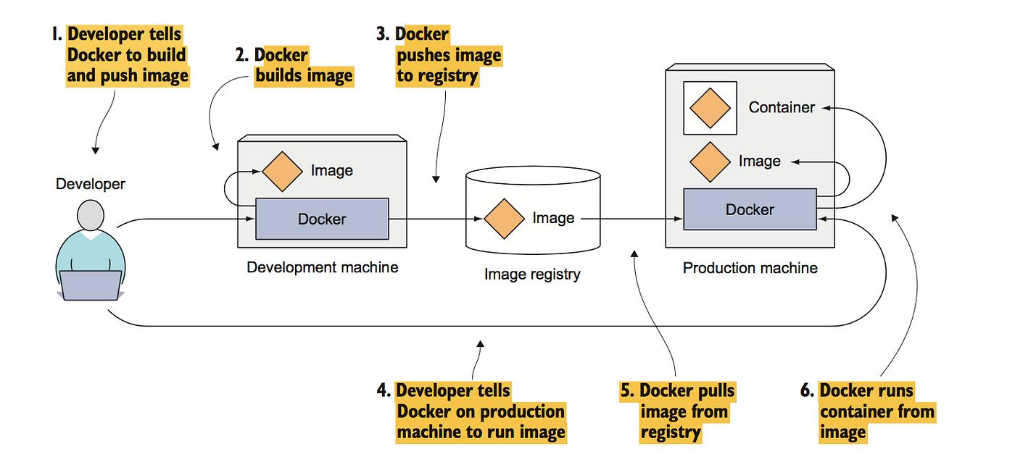

16. Describe the architecture and working of Docker.
Docker Architecture Overview
- Docker architecture follows a client-server model where the client communicates with the Docker daemon effectively.
- The Docker daemon handles container creation, image management, and execution processes within the host system.
- Docker architecture enables efficient containerization and resource utilization across development environments consistently.
Docker Client
- The Docker client is the interface through which developers interact with Docker using commands like docker run.
- It sends requests to the Docker daemon for executing container-related operations efficiently.
- Developers use command-line interface or GUI tools to communicate with Docker client systems effectively.

Docker Daemon
- The Docker daemon is responsible for managing images, containers, networks, and storage within Docker environments.
- It listens to API requests and performs operations such as building images and running containers accordingly.
- The daemon ensures proper execution and lifecycle management of containers within the host system consistently.

Docker Images
- Docker images are read-only templates used for creating containers with predefined configurations and dependencies.
- Images are stored locally or in registries and can be reused for creating multiple containers efficiently.
- Layered image structure improves storage efficiency and reduces duplication during container creation processes.

Docker Containers
- Containers are runtime instances of Docker images executing applications in isolated environments independently.
- They share host system resources while maintaining separation from other containers effectively.
- Containers can be easily managed, scaled, and removed based on application requirements efficiently.

Docker Registry
- Docker registry is used for storing and distributing Docker images across different systems efficiently.
- Developers push and pull images from registries like Docker Hub for collaboration purposes.
- Registries ensure centralized image storage and accessibility for deployment processes consistently.

Working of Docker
- Developers create Dockerfiles, build images, run containers, and push images to registries for deployment workflows.
- Docker client sends commands to daemon, which processes requests and manages container operations accordingly.
- This workflow ensures efficient containerization and consistent application deployment across environments effectively.

Importance of Docker Architecture
- Docker architecture simplifies application deployment and improves resource utilization within development environments effectively.
- It supports scalability, portability, and automation for modern cloud-native applications efficiently.
- Understanding architecture helps developers design efficient container-based application systems successfully.
Docker Architecture Diagram
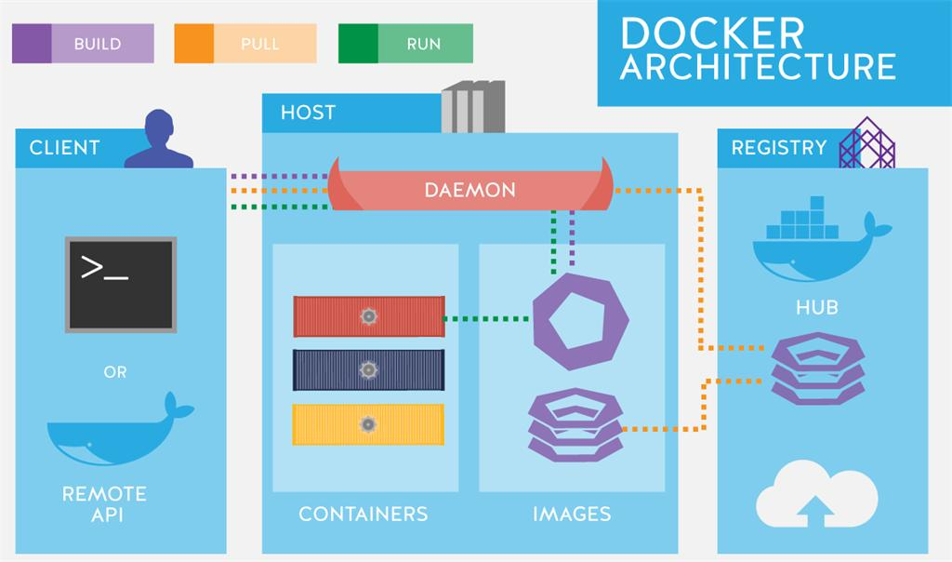
17. Explain the steps to install Docker on Windows and Linux.
Introduction to Docker Installation
- Docker installation is the process of setting up the containerization platform on operating systems for development purposes.
- It enables developers to run, build, and manage containers efficiently within their local or production environments.
- Proper installation ensures smooth execution of Docker commands and container lifecycle operations consistently afterward.

Installing Docker on Windows
- Developers download Docker Desktop from the official Docker website and ensure system compatibility before installation.
- The installer includes Docker Engine, CLI tools, and Kubernetes support for container orchestration features.
- Windows installation requires enabling virtualization features such as Hyper-V or WSL2 for proper Docker functionality.

Running the Installer
- Users execute the downloaded installer file and follow step-by-step instructions provided by the installation wizard.
- Installation settings allow configuration of system resources, backend engine, and integration with Windows environments.
- Default settings are usually sufficient for most development scenarios and simplify installation processes effectively.

Completing Installation on Windows
- After installation, Docker Desktop starts automatically and configures required services for container operations efficiently.
- Developers verify installation using the docker --version command within command prompt or terminal environments.
- Successful installation ensures Docker commands execute correctly without configuration errors or missing dependencies.

Installing Docker on Linux
- Linux users install Docker using package managers such as apt, yum, or dnf depending on their distribution environment.
- Commands like sudo apt install docker.io or sudo yum install docker are commonly used for installation processes.
- Docker packages include daemon, CLI tools, and dependencies required for running containerized applications efficiently.

Starting Docker Services
- Developers start Docker services using commands like sudo systemctl start docker after installation completes successfully.
- Enabling Docker service ensures automatic startup during system boot for continuous container management operations.
- Proper service configuration ensures Docker daemon runs continuously without interruptions during development workflows.
Verifying Installation
- Developers check installation using commands like docker --version and docker info to confirm proper setup.
- Running test containers like docker run hello-world verifies correct installation and container execution successfully.
- Verification ensures Docker environment is ready for development and deployment of containerized applications effectively.

Importance of Docker Installation
- Proper Docker installation ensures reliable container execution and efficient application deployment across environments consistently.
- It provides a foundation for learning advanced containerization, orchestration, and DevOps practices effectively.
- Installation is the first step toward building scalable, portable, and efficient modern software applications successfully.
Docker Installation Workflow
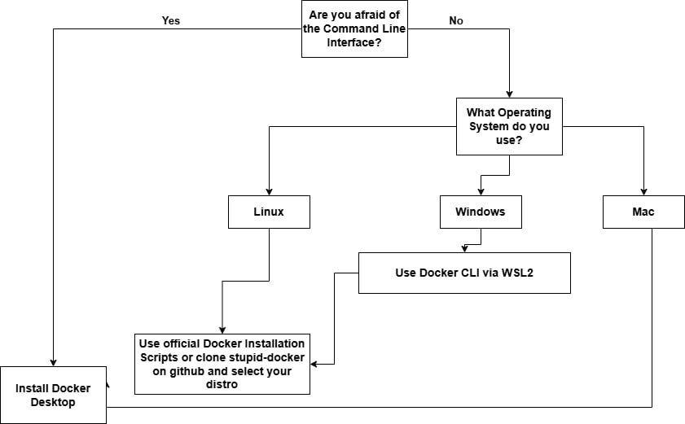
18. Discuss various Docker operations with examples.
Introduction to Docker Operations
- Docker operations include commands used for building images, running containers, and managing containerized applications efficiently.
- These operations help developers automate workflows and simplify application deployment processes significantly.
- Understanding Docker commands improves productivity and enables efficient management of development environments consistently.

Building Docker Images
- Developers use the docker build command to create images from Dockerfiles containing application configuration instructions.
- Example: docker build -t myapp:1.0 . creates an image named myapp with version tag 1.0 successfully.
- Building images ensures consistent environments for running applications across development and production systems effectively.

Running Containers
- Developers use the docker run command to create and execute containers from Docker images efficiently.
- Example: docker run -d -p 8080:80 nginx runs an Nginx container in detached mode successfully.
- Running containers allows applications to execute in isolated environments with specified configurations and resources.

Listing Containers and Images
- The docker ps command displays running containers, while docker images lists available images in local systems.
- Example: docker ps -a shows all containers including stopped ones for management purposes effectively.
- These commands help developers monitor container status and manage image repositories efficiently.

Stopping and Removing Containers
- Developers use docker stop container_id to stop running containers and docker rm container_id to remove them.
- Example: docker stop abc123 stops a container with the specified ID successfully.
- Removing unused containers helps free system resources and maintain clean development environments effectively.

Managing Images
- Developers use docker rmi image_name to remove unused images from local storage systems efficiently.
- Example: docker rmi myapp:1.0 deletes the specified Docker image successfully.
- Image management improves storage efficiency and ensures updated versions are used for application deployment consistently.

Pulling and Pushing Images
- Developers use docker pull to download images and docker push to upload images to registries like Docker Hub.
- Example: docker pull ubuntu:latest downloads the Ubuntu image successfully.
- These operations enable collaboration and sharing of containerized applications across teams efficiently.

Importance of Docker Operations
- Docker operations automate container lifecycle management and simplify application deployment workflows effectively.
- They improve development efficiency and reduce manual configuration efforts significantly during software development processes.
- Understanding these operations is essential for mastering container-based application development and deployment successfully.

Docker Operations Workflow
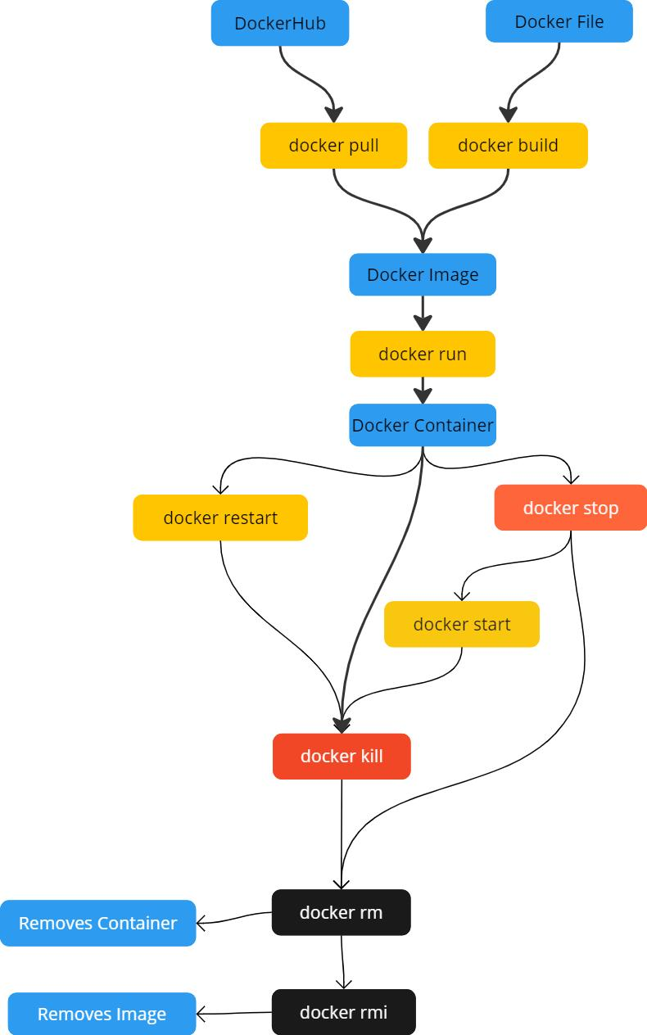

19. Explain Docker concepts: Registry, Repository, Tag, Image, and Container.
Introduction to Docker Concepts
- Docker concepts form the foundation for understanding containerization and managing application deployment processes efficiently.
- These components work together to build, store, and run containerized applications across environments consistently.
- Understanding these concepts improves efficiency in using Docker tools for development and deployment workflows.

Docker Registry
- A Docker registry is a storage system used for managing and distributing Docker images across different environments efficiently.
- Public registries like Docker Hub provide centralized image storage for developers worldwide.
- Private registries ensure secure storage and controlled access for enterprise-level application deployment workflows effectively.

Docker Repository
- A repository is a collection of related Docker images stored under a common name within a registry system efficiently.
- It allows version control and organization of images for different application versions or configurations consistently.
- Developers can manage multiple versions of applications within a single repository using tags effectively.

Docker Tag
- A tag is a label used to identify specific versions of Docker images within repositories efficiently.
- Tags help developers manage application versions and ensure correct image deployment across environments consistently.
- Example: nginx:latest or nginx:1.21 represents different versions of the same image effectively.

Docker Image
- A Docker image is a read-only template containing application code, dependencies, and configuration settings required for execution.
- Images serve as the base for creating containers and ensure consistent runtime environments across systems effectively.
- They are built using Dockerfiles and stored in registries for sharing and reuse across development teams efficiently.

Docker Container
- A container is a runtime instance of a Docker image executing applications in isolated environments independently.
- Containers include necessary libraries and configurations for running applications consistently across different systems effectively.
- They are lightweight, portable, and easy to manage compared to traditional virtual machines significantly.

Relationship Between Concepts
- Images are stored in repositories within registries and are used to create containers during runtime operations efficiently.
- Tags identify different versions of images within repositories for version control and deployment management consistently.
- These concepts collectively enable efficient containerization and application deployment workflows successfully.

Importance of Docker Concepts
- Understanding Docker concepts helps developers build scalable, portable, and efficient container-based applications effectively.
- These concepts improve collaboration, version control, and deployment processes within modern DevOps environments significantly.
- Mastery of these fundamentals is essential for working with container orchestration tools and cloud-based applications successfully.

Docker Concepts Diagram

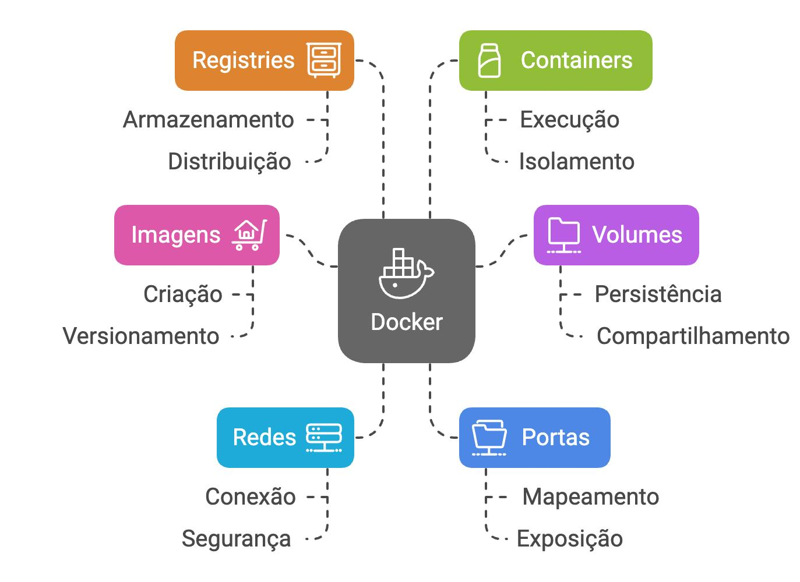
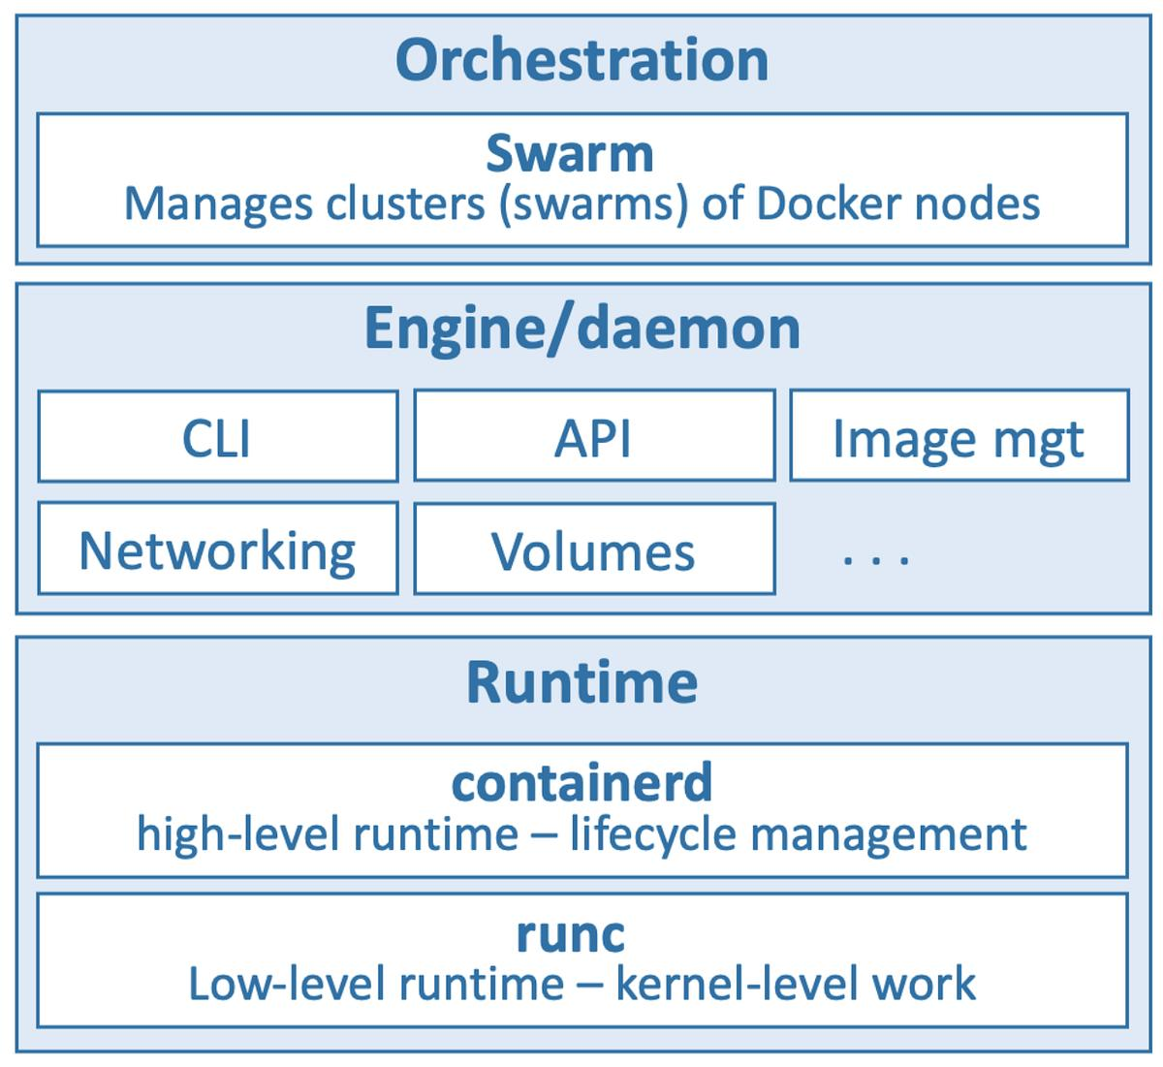

20. Describe the process of creating a Docker Hub account and its importance.
Introduction to Docker Hub
- Docker Hub is a cloud-based platform used for storing, managing, and sharing Docker images globally.
- It provides developers with repositories to host container images for collaboration and deployment purposes efficiently.
- Docker Hub acts as a central registry enabling easy access to containerized applications across different environments consistently.

Creating Docker Hub Account
- Users visit the official Docker Hub website and click on the sign-up option to create a new account.
- They provide required details such as username, email address, and password during registration process carefully.
- Account verification is completed through email confirmation ensuring secure access to Docker Hub services effectively.

Logging into Docker Hub
- After account creation, users log in using their credentials through Docker CLI or Docker Desktop interface efficiently.
- The docker login command is used in terminal environments to authenticate Docker Hub accounts successfully.
- Login authentication allows users to access private repositories and perform image management operations securely.

Creating a Repository
- Users create repositories on Docker Hub for storing Docker images under specific project names efficiently.
- Repositories can be public or private depending on project requirements and security considerations effectively.
- Proper repository naming improves organization and accessibility of container images during development workflows consistently.

Uploading Docker Images
- Developers push Docker images to Docker Hub using the docker push command after tagging images correctly.
- Example: docker push username/app:1.0 uploads the image to Docker Hub repository successfully.
- Uploaded images become accessible for deployment, sharing, and collaboration across development teams efficiently.

Managing Docker Hub Repositories
- Users can update, delete, or modify repositories and images using Docker Hub web interface or CLI commands effectively.
- Repository settings allow access control, visibility configuration, and version management for container images securely.
- Proper management ensures efficient handling of application images across development and production environments consistently.

Importance of Docker Hub
- Docker Hub enables centralized storage and sharing of container images across distributed development teams efficiently.
- It supports CI/CD integration for automated image building and deployment processes effectively.
- Docker Hub simplifies collaboration and improves accessibility of containerized applications globally.

Security and Access Control
- Docker Hub provides authentication mechanisms for secure access to repositories and images effectively.
- Private repositories ensure restricted access for sensitive applications and enterprise-level deployments consistently.
- Access tokens and credentials improve security and prevent unauthorized usage of container images significantly.
Docker Hub Workflow Diagram
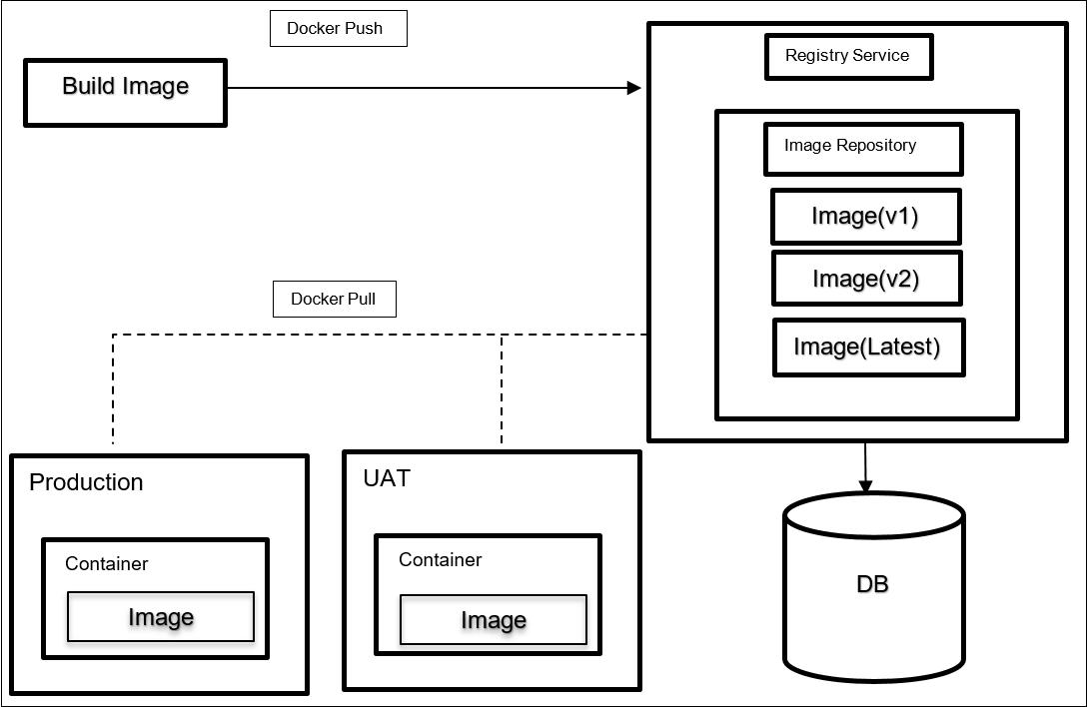

21. Explain Docker images and containers with suitable examples.
Introduction to Images and Containers
- Docker images and containers are fundamental components used for building and running containerized applications efficiently.
- Images act as templates, while containers are executable instances of those templates during runtime environments.
- Understanding both concepts helps developers manage application deployment and execution processes effectively.

Docker Images Overview
- Docker images are read-only templates containing application code, dependencies, and configuration settings required for execution.
- Images are built using Dockerfiles and stored locally or in registries for reuse across development environments efficiently.
- They follow layered architecture allowing reuse of components and efficient storage management during builds consistently.

Docker Containers Overview
- Containers are runtime instances of Docker images executing applications in isolated environments independently.
- They include runtime, system tools, and libraries required for running applications consistently across systems effectively.
- Containers are lightweight and share host OS kernel, improving efficiency compared to traditional virtual machines significantly.

Example of Docker Image
- Example: ubuntu:latest is a Docker image providing a base Linux environment for application development processes.
- Developers use this image to create containers and install additional software for application execution effectively.
- Another example includes nginx image used for running web servers within containerized environments efficiently.

Example of Docker Container
- Running docker run -d nginx creates a container from nginx image and starts a web server successfully.
- Each container operates independently and can be configured with ports, volumes, and environment variables effectively.
- Multiple containers can be created from the same image for scaling applications efficiently.

Differences Between Image and Container
- Images are static templates, while containers are dynamic runtime instances executing applications effectively.
- Images remain unchanged unless rebuilt, whereas containers can be modified during execution processes.
- Containers depend on images, but images do not depend on containers for existence consistently.

Relationship Between Images and Containers
- Images serve as the base for creating containers during runtime operations efficiently.
- Containers inherit properties defined in images including dependencies and configurations consistently.
- This relationship ensures consistent application execution across different development environments effectively.

Importance of Images and Containers
- Images and containers simplify deployment and ensure consistent application behavior across environments efficiently.
- They improve scalability, portability, and efficiency in modern DevOps and cloud-based development workflows.
- Understanding these concepts is essential for working with containerized applications successfully.

Docker Image vs Container Diagram
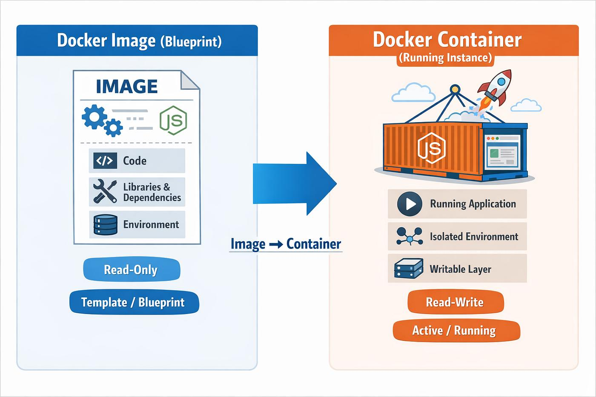
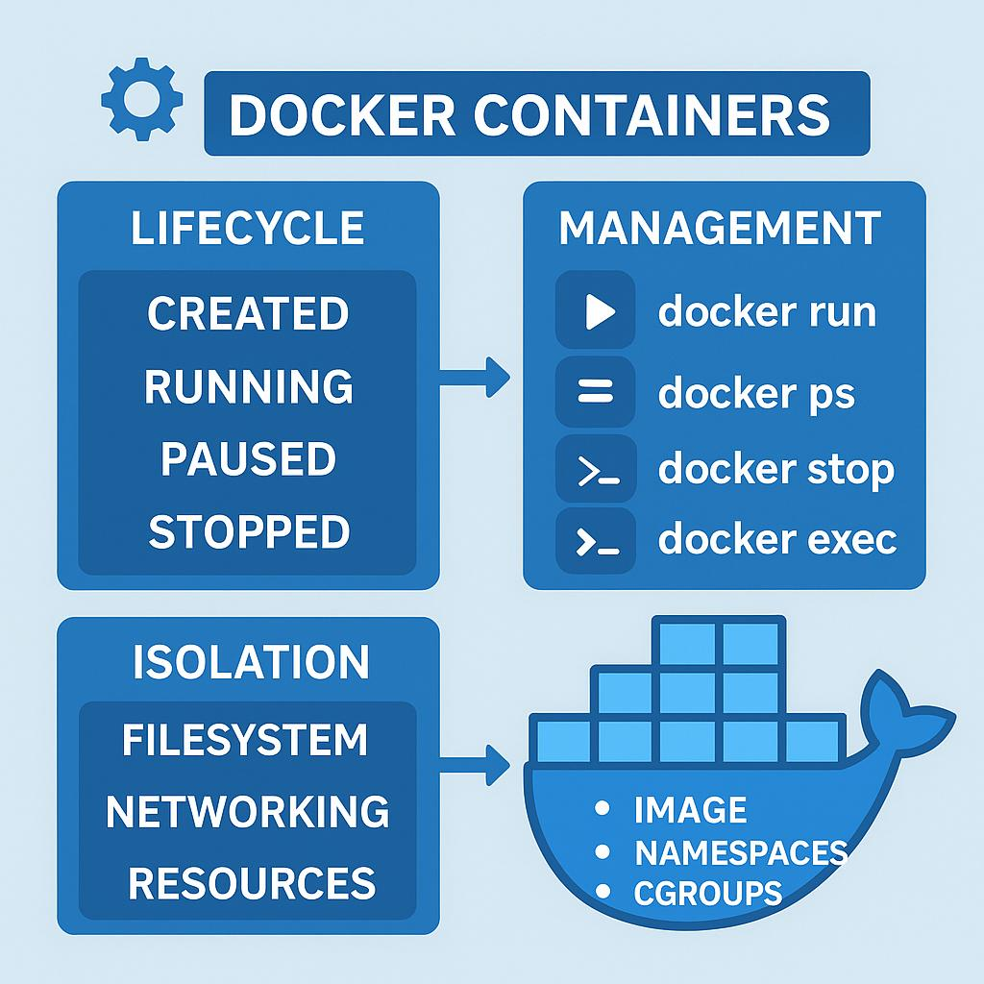

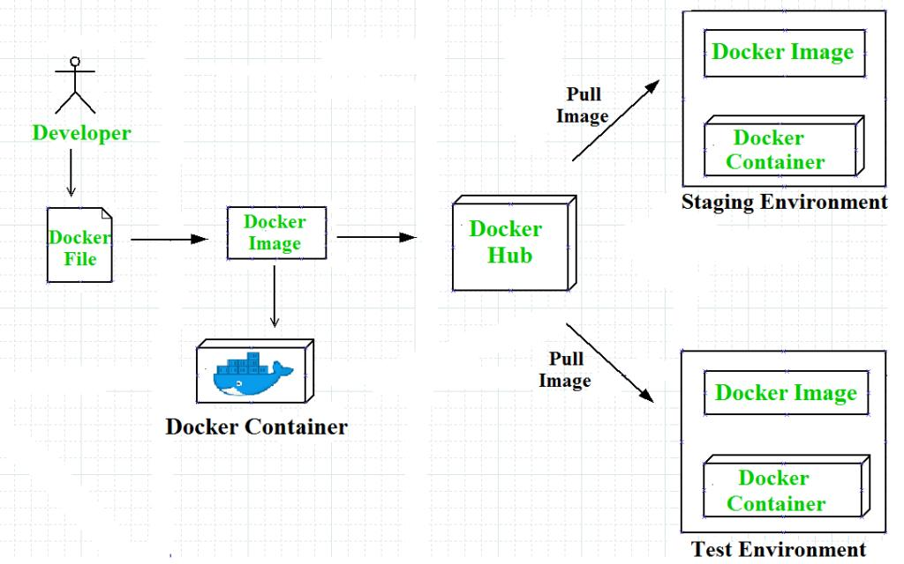

22. Demonstrate how to create and manage Docker containers.
Introduction to Container Management
- Docker container management involves creating, running, stopping, and removing containers efficiently.
- It helps developers control application execution within isolated environments consistently.
- Proper management improves resource utilization and application performance during runtime operations effectively.

Creating Containers
- Developers create containers using docker run command specifying image and required configuration options efficiently.
- Example: docker run -it ubuntu creates an interactive container for Ubuntu environment successfully.
- Container creation initializes application environment based on image configuration settings effectively.

Running Containers
- Containers can be run in foreground or detached mode depending on application requirements efficiently.
- Example: docker run -d nginx runs a container in background mode successfully.
- Running containers allows applications to execute continuously within isolated environments effectively.

Listing Containers
- Developers use docker ps to list running containers and docker ps -a to display all containers efficiently.
- This command helps monitor container status and manage running instances effectively.
- Listing containers ensures visibility of active and inactive containers within Docker environments consistently.

Stopping Containers
- Developers use docker stop container_id to stop running containers gracefully efficiently.
- Example: docker stop abc123 stops a specific container successfully.
- Stopping containers ensures proper shutdown of application processes without data loss effectively.

Removing Containers
- Containers can be removed using docker rm container_id after stopping them successfully.
- Removing containers helps free system resources and maintain clean development environments efficiently.
- Example: docker rm abc123 deletes the container permanently from the system successfully.

Inspecting Containers
- Developers use docker inspect container_id to view detailed information about container configurations effectively.
- It provides data such as IP address, environment variables, and resource allocation for debugging purposes efficiently.
- Inspection improves troubleshooting and container management processes significantly.

Importance of Container Management
- Effective container management improves system performance and ensures efficient application execution consistently.
- It enables scalability and resource optimization within containerized development environments effectively.
- Understanding container management is essential for deploying and maintaining Docker-based applications successfully.

Docker Container Management Workflow
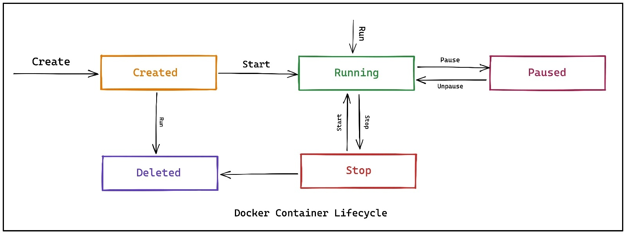
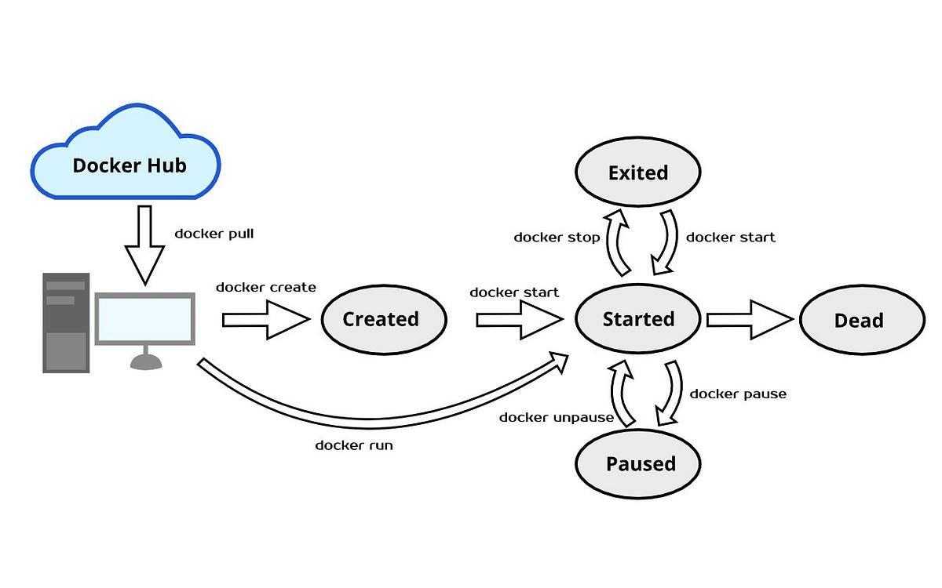


23. Explain the process of pushing Docker images to Docker Hub.
Introduction to Image Pushing
- Pushing Docker images involves uploading locally built container images to a remote registry for sharing and deployment.
- It allows developers to distribute applications across teams and environments efficiently using centralized repositories.
- The process ensures that container images are available remotely for deployment in production or testing environments.

Preparing Docker Image
- Developers first build a Docker image using a Dockerfile and verify it exists locally before pushing.
- Example: docker build -t myapp:1.0 . creates a local image ready for upload operations.
- Proper image preparation ensures successful upload without errors or missing dependencies during push operations.

Tagging the Image
- Docker images must be tagged with repository name and username before pushing to Docker Hub successfully.
- Example: docker tag myapp username/myapp:1.0 prepares image for remote repository upload effectively.
- Tagging ensures correct identification and versioning of images within Docker Hub repositories.

Logging into Docker Hub
- Developers authenticate using docker login command before performing push operations to Docker Hub repositories.
- Login ensures secure access and permission to upload images into specific repositories successfully.
- Proper authentication prevents unauthorized access and protects container images effectively.

Pushing the Image
- Developers use docker push username/myapp:1.0 command to upload images into Docker Hub repositories.
- The command transfers image layers efficiently to remote registry ensuring proper storage and accessibility.
- Successful push makes the image available for download and deployment across environments.

Verifying Uploaded Image
- Developers verify image upload by checking Docker Hub repository through web interface or CLI commands.
- Verification ensures that correct image version is uploaded and available for future use successfully.
- Proper validation prevents deployment errors and ensures consistency in application environments.
Updating Images
- Developers rebuild and push updated images whenever application changes are made efficiently.
- Tags help manage versions such as 1.0, 2.0, or latest for different application releases.
- Version updates ensure proper tracking and rollback capability during deployment workflows.
Importance of Image Pushing
- Pushing images enables collaboration, sharing, and deployment across distributed systems effectively.
- It supports CI/CD pipelines and automation for modern DevOps workflows efficiently.
- This process ensures application portability and accessibility across different environments consistently.

Docker Push Workflow

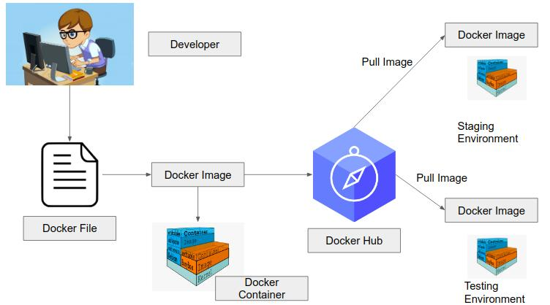

24. Describe how to pull images from Docker Hub and run containers.
Introduction to Pulling Images
- Pulling images involves downloading Docker images from remote registries like Docker Hub to local systems.
- It allows developers to access pre-built images for running applications quickly without building them manually.
- Pull operations simplify development workflows and reduce setup time significantly.

Pulling Docker Images
- Developers use docker pull image_name command to download images from Docker Hub repositories efficiently.
- Example: docker pull nginx downloads the latest version of nginx image successfully.
- Pulling ensures availability of required images before container execution processes begin.

Specifying Image Tags
- Developers can pull specific versions using tags like docker pull nginx:1.21 for controlled deployment processes.
- Tags ensure correct application version is used during container execution consistently.
- Proper version selection improves stability and avoids compatibility issues effectively.

Running Containers from Pulled Images
- Developers use docker run command to create containers from downloaded images efficiently.
- Example: docker run -d -p 8080:80 nginx runs a container mapping ports successfully.
- Running containers enables application execution within isolated environments consistently.

Managing Running Containers
- Developers use docker ps to view active containers and monitor application execution effectively.
- Containers can be stopped using docker stop and restarted using docker start commands efficiently.
- Proper management ensures smooth execution and maintenance of containerized applications consistently.

Removing Containers
- Developers remove unused containers using docker rm container_id to free system resources effectively.
- Cleanup improves performance and maintains organized development environments efficiently.
- Removing containers ensures only necessary instances are running within the system.

Verifying Application Execution
- Developers verify running applications using browser access or container logs effectively.
- Example: Accessing localhost:8080 confirms successful nginx container execution.
- Verification ensures application is working correctly within container environment consistently.

Importance of Pull and Run Process
- Pulling and running images simplifies deployment and reduces development setup complexity significantly.
- It enables reuse of existing images and improves efficiency in application execution workflows effectively.
- This process is essential for rapid development and testing in container-based environments.

Pull and Run Workflow

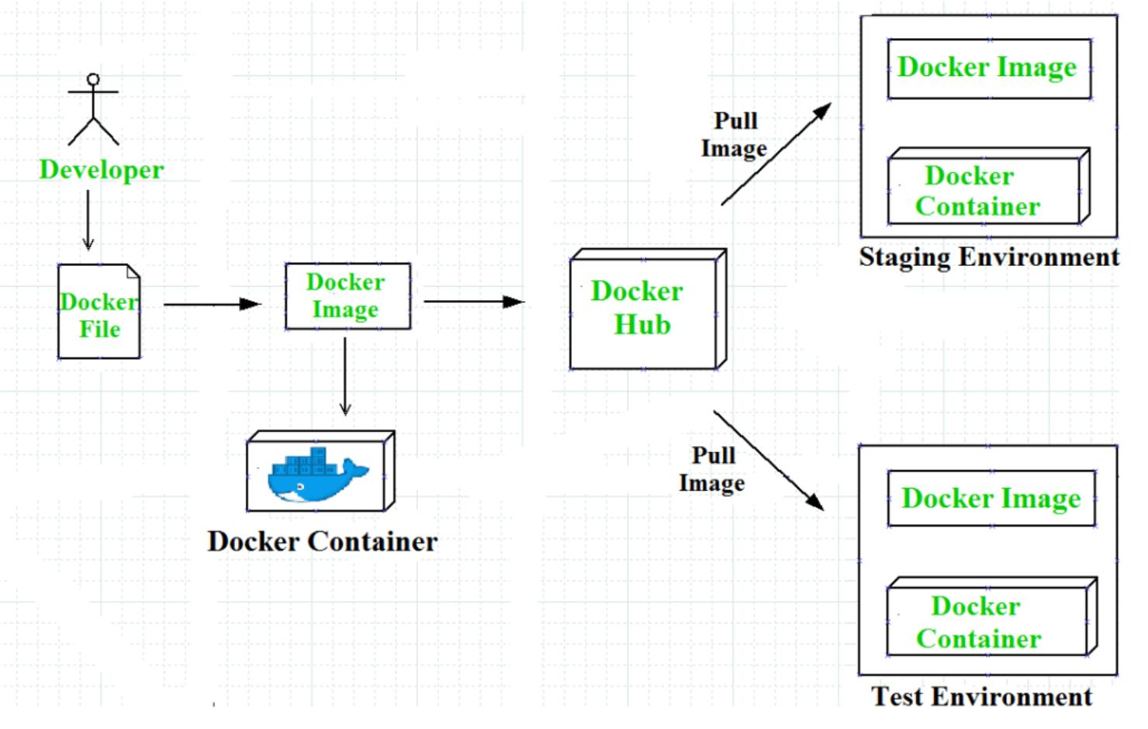

25. Explain Dockerfile and its instructions with an example.
Introduction to Dockerfile
- A Dockerfile is a script containing instructions to build Docker images automatically and consistently.
- It defines application environment, dependencies, and execution commands required for container creation.
- Dockerfiles ensure reproducibility of environments across different systems effectively.

Structure of Dockerfile
- Dockerfile consists of sequential instructions executed during image build process efficiently.
- Each instruction creates a new layer contributing to the final Docker image structure.
- Structured Dockerfiles improve readability and maintainability of application configuration effectively.

Common Instructions
- FROM specifies base image, RUN executes commands, and COPY transfers files into image environment.
- CMD defines default command executed when container starts successfully.
- EXPOSE specifies network ports used by applications inside containers efficiently.

Example Dockerfile
- Example:
- FROM ubuntu
- RUN apt update
- COPY app.py /app/
- CMD ["python3","/app/app.py"]
- This file creates an image with Ubuntu base and runs Python application successfully.
- Example demonstrates basic instructions used in Dockerfile creation effectively.

Building Image from Dockerfile
- Developers use docker build -t myapp . command to create images from Dockerfile instructions efficiently.
- Build process executes instructions sequentially and generates image layers successfully.
- Proper build ensures consistent application environment across systems effectively.

Advantages of Dockerfile
- Dockerfiles automate environment setup and reduce manual configuration efforts significantly.
- They improve consistency and reliability in application deployment processes effectively.
- Dockerfiles simplify collaboration by providing standard configuration scripts for developers.

Best Practices
- Developers should minimize layers and use efficient commands to optimize image size effectively.
- Proper use of caching improves build performance and reduces resource usage significantly.
- Clear structure and comments improve readability and maintainability of Dockerfiles consistently.

Importance of Dockerfile
- Dockerfiles are essential for containerization and ensure reproducible builds across environments effectively.
- They simplify DevOps workflows and improve automation of deployment processes significantly.
- Understanding Dockerfile is critical for building efficient container-based applications successfully.

Dockerfile Workflow

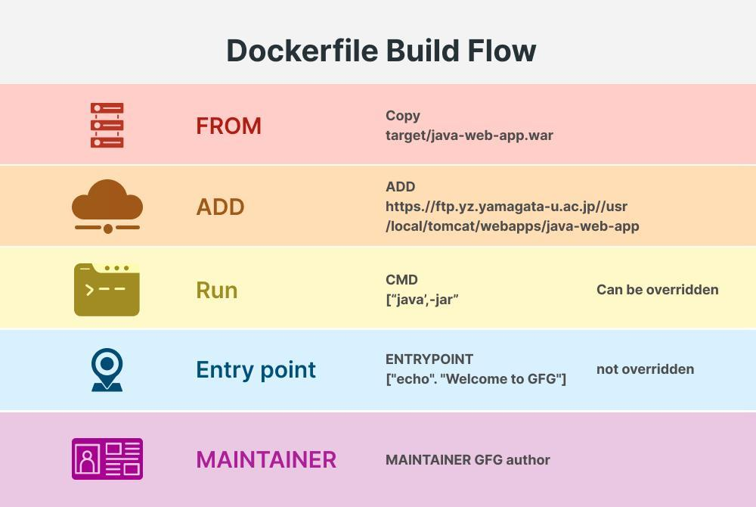

26. Explain multi-stage Dockerfile with a practical example and its advantages.
Introduction to Multi-stage Builds
- Multi-stage Dockerfiles allow building images using multiple stages to optimize final image size efficiently.
- They separate build environment from runtime environment within a single Dockerfile effectively.
- This approach improves efficiency and reduces unnecessary dependencies in final images significantly.

Structure of Multi-stage Dockerfile
- Multi-stage builds use multiple FROM statements to define different stages within Dockerfile.
- Each stage performs specific tasks such as building, compiling, or packaging application components efficiently.
- Final stage copies only required files from previous stages into production image effectively.

Practical Example
- Example:
- FROM node AS build
- WORKDIR /app
- COPY . .
- RUN npm install

- FROM nginx
- COPY --from=build /app /usr/share/nginx/html
- First stage builds application, second stage runs it using nginx server successfully.
- Example demonstrates separation of build and runtime environments effectively.

Advantages of Multi-stage Builds
- Multi-stage builds reduce final image size by excluding unnecessary build dependencies effectively.
- They improve security by minimizing attack surface in production images significantly.
- Efficient builds improve performance and reduce deployment time across environments consistently.

Optimization Techniques
- Developers use minimal base images like alpine to reduce image size effectively.
- Proper layer management improves caching and build performance significantly.
- Removing temporary files during build reduces storage usage efficiently.
Use Cases
- Multi-stage builds are useful for compiling applications in languages like Java, Node.js, and Go efficiently.
- They are commonly used in CI/CD pipelines for optimized container image creation effectively.
- Suitable for production environments requiring lightweight and secure images consistently.
Best Practices
- Keep stages clearly defined and use descriptive names for better readability effectively.
- Use minimal runtime images to improve efficiency and security significantly.
- Avoid unnecessary dependencies in final stage for optimized container performance consistently.
Importance of Multi-stage Builds
- Multi-stage builds improve efficiency, security, and maintainability of Docker images effectively.
- They simplify development workflows and optimize container deployment processes significantly.
- Understanding this concept is essential for creating production-ready container images successfully.
Multi-stage Dockerfile Workflow
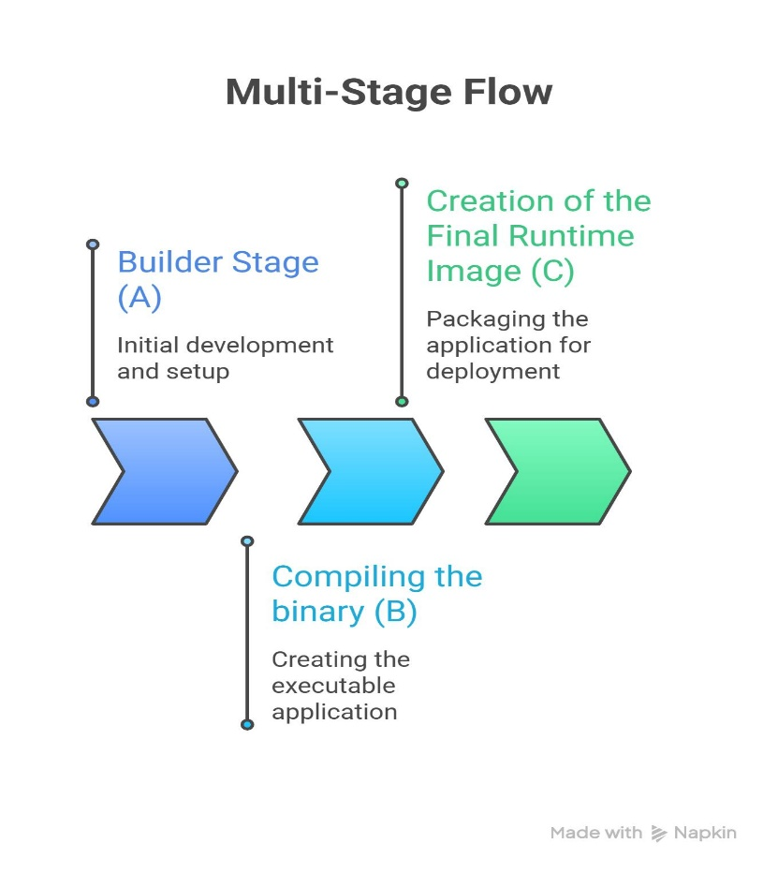

27. Discuss Docker volumes and their importance in data persistence.
Introduction to Docker Volumes
- Docker volumes are storage mechanisms used to persist data generated by containers beyond their lifecycle effectively.
- They allow containers to store data outside the container filesystem, ensuring data is not lost when containers are removed.
- Volumes provide a reliable way to manage application data independently from container execution environments consistently.
- They are widely used in databases and applications requiring long-term data storage across multiple container restarts.
Types of Docker Volumes
- Docker supports named volumes, anonymous volumes, and bind mounts for different storage requirements efficiently.
- Named volumes are managed by Docker and provide easy reuse across multiple containers within the same environment.
- Bind mounts connect container directories directly to host system directories for flexible file access and modification.
- Anonymous volumes are automatically created without specific names and are mainly used for temporary storage purposes.
Creating Docker Volumes
- Developers create volumes using docker volume create volume_name command for persistent storage management effectively.
- Volumes can also be created automatically when specified in docker run command during container creation processes.
- Example: docker run -v myvolume:/data ubuntu creates and attaches volume to container successfully.
- Creating volumes ensures data generated inside containers remains accessible even after container deletion.
Managing Docker Volumes
- Developers use docker volume ls to list all available volumes within the Docker environment efficiently.
- The docker volume inspect command provides detailed information about specific volumes for debugging purposes.
- Volumes can be removed using docker volume rm volume_name when no longer needed effectively.
- Proper volume management helps maintain organized storage and prevents unnecessary resource usage within systems.
Data Persistence
- Docker volumes ensure data persistence even when containers are stopped, removed, or recreated successfully.
- They allow applications such as databases to store critical data safely across container lifecycle operations effectively.
- Data stored in volumes is independent of container filesystem, ensuring reliability and durability consistently.
- Persistence improves application stability and reduces risk of data loss during deployment or updates.
Sharing Data Between Containers
- Volumes enable multiple containers to share the same data for collaborative application operations efficiently.
- Example: A database container and application container can access shared volume for data exchange processes.
- Shared volumes improve communication between containers within microservices architectures effectively.
- This feature enhances scalability and modular design of containerized applications significantly.
Advantages of Docker Volumes
- Volumes improve data management by separating storage from container lifecycle effectively.
- They enhance performance compared to bind mounts because Docker manages storage more efficiently internally.
- Volumes provide better security and access control compared to direct host file system access consistently.
- They simplify backup and migration of data across environments during deployment processes efficiently.

Importance of Docker Volumes
- Docker volumes are essential for maintaining persistent data in containerized applications effectively.
- They support scalable and reliable storage solutions within modern DevOps and cloud-native environments.
- Volumes enable efficient data sharing and improve application performance across distributed systems consistently.
- Understanding volumes is critical for managing production-level applications requiring long-term data storage successfully.

Docker Volumes Workflow

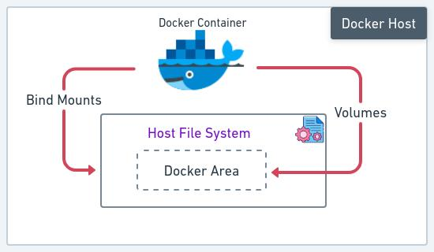

28. Explain the complete workflow from Dockerfile to Docker Hub deployment.
Introduction to Docker Workflow
- Docker workflow includes steps from writing Dockerfile to deploying images on Docker Hub for sharing and execution.
- It ensures consistent application packaging, distribution, and deployment across multiple environments efficiently.
- The workflow simplifies DevOps processes and supports continuous integration and delivery pipelines effectively.
- Understanding the workflow helps developers automate application deployment processes successfully.

Writing Dockerfile
- Developers create Dockerfile defining base image, dependencies, and commands required for application setup processes.
- Dockerfile acts as blueprint for building images ensuring consistent environment creation across systems effectively.
- Properly structured Dockerfiles improve maintainability and readability of application configuration workflows.
- Commands like FROM, RUN, COPY, and CMD are commonly used to define application environment effectively.

Building Docker Image
- Developers build images using docker build -t appname:version . command from Dockerfile instructions efficiently.
- Build process executes instructions sequentially and creates layered image structure successfully.
- Image building ensures application environment is packaged with all required dependencies consistently.
- Built images are stored locally before being pushed to Docker Hub repositories effectively.

Testing Docker Container
- Developers run containers using docker run command to verify application functionality before deployment effectively.
- Testing ensures application works correctly inside container environment without errors or missing dependencies.
- Containers can be tested using logs, browser access, or API responses depending on application type consistently.
- Proper testing reduces deployment failures and improves application reliability significantly.

Tagging Docker Image
- Developers tag images using docker tag command to prepare them for pushing to Docker Hub repositories effectively.
- Tags help identify application versions and ensure correct deployment across environments consistently.
- Example: docker tag appname username/appname:1.0 prepares image for remote upload successfully.
- Proper tagging improves version control and management of application images efficiently.

Pushing to Docker Hub
- Developers push images using docker push username/appname:1.0 command to upload images to Docker Hub successfully.
- Pushing ensures images are accessible remotely for deployment and collaboration across development teams effectively.
- Docker Hub acts as centralized repository for storing and managing container images efficiently.
- Upload process transfers image layers securely to remote registry systems consistently.
Deploying from Docker Hub
- Developers pull images using docker pull command and run containers in production environments efficiently.
- Deployment ensures applications run consistently across servers using same container image configurations effectively.
- Docker Hub integration supports CI/CD pipelines for automated deployment workflows successfully.
- Deployment process improves scalability and reliability of containerized applications significantly.
Importance of Workflow
- Complete workflow ensures efficient containerization and deployment of applications across environments consistently.
- It improves collaboration, automation, and scalability within modern software development practices effectively.
- Understanding workflow helps developers manage application lifecycle efficiently using Docker tools successfully.
- This workflow is essential for DevOps engineers and cloud-native application development processes.
Docker Workflow Diagram

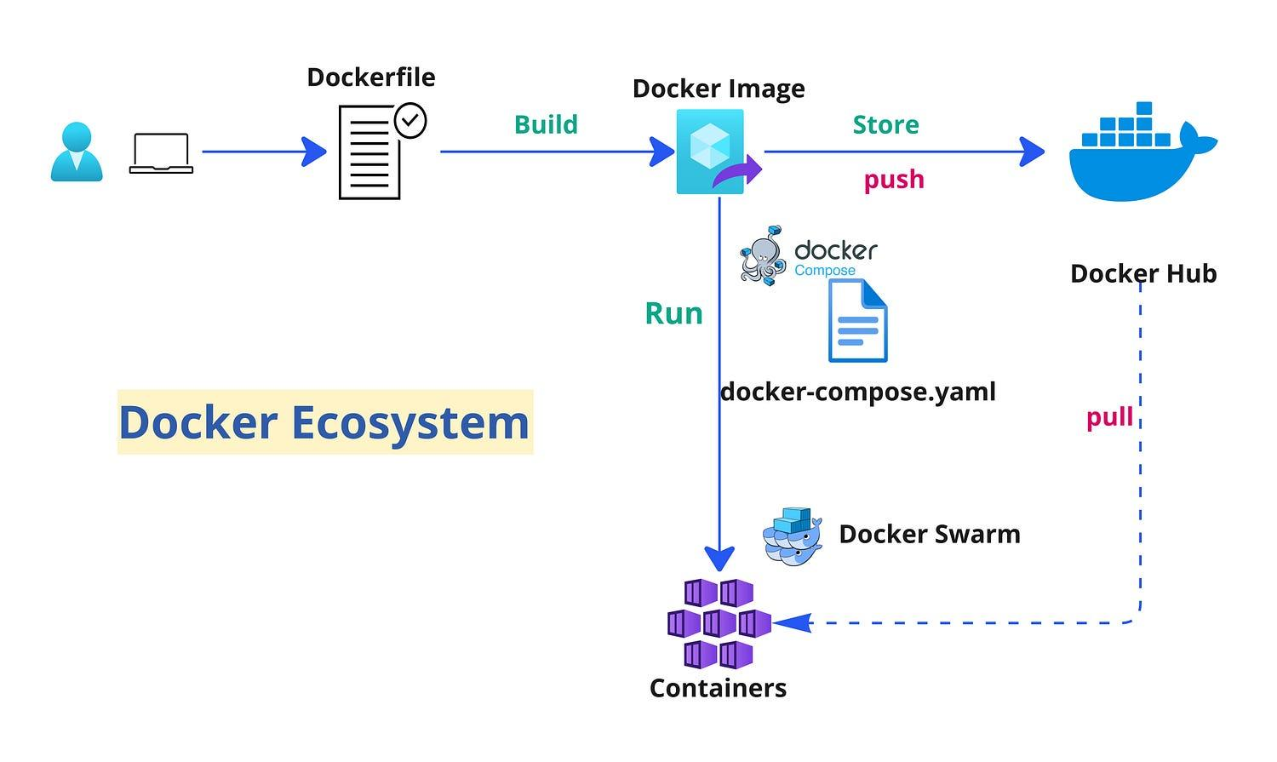

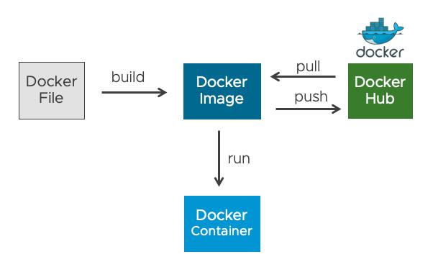
29. Compare Docker images, containers, and volumes with practical scenario.
Introduction to Comparison
- Docker images, containers, and volumes are core components of containerization with different roles in application deployment.
- Images act as templates, containers run applications, and volumes store persistent data effectively.
- Understanding differences helps developers design efficient container-based application architectures successfully.
- Each component plays a unique role in ensuring application functionality, scalability, and reliability consistently.

Docker Images
- Images are read-only templates containing application code, dependencies, and configurations required for execution effectively.
- They are built using Dockerfiles and stored in registries for reuse across multiple environments efficiently.
- Images cannot be modified during runtime and require rebuilding for changes to take effect consistently.
- Multiple containers can be created from a single image without affecting its original structure significantly.

Docker Containers
- Containers are runtime instances of images executing applications in isolated environments independently.
- They include runtime, libraries, and dependencies required for application execution consistently.
- Containers can be started, stopped, modified, and removed dynamically during runtime operations effectively.
- They provide isolation and portability, ensuring consistent behavior across development and production systems.

Docker Volumes
- Volumes are storage systems used for persisting data generated by containers beyond their lifecycle effectively.
- They allow containers to store data outside container filesystem ensuring data safety and durability consistently.
- Volumes can be shared between multiple containers for data exchange and collaboration efficiently.
- They improve performance and reliability compared to storing data within container filesystem directly.

Key Differences
- Images are static templates, containers are executable instances, and volumes are persistent storage mechanisms effectively.
- Images define application structure, containers run applications, and volumes manage data storage consistently.
- Containers depend on images, while volumes operate independently of container lifecycle effectively.
- Each component contributes to efficient containerization and deployment workflows successfully.

Practical Scenario
- Example: A web application uses an image for application code, container for execution, and volume for database storage effectively.
- Database container stores data in volume ensuring persistence even when container is restarted or removed.
- Application container uses same image for scaling across multiple instances efficiently.
- This scenario demonstrates how all three components work together in real-world applications successfully.

Advantages of Combined Usage
- Combining images, containers, and volumes improves scalability, reliability, and efficiency of applications effectively.
- It ensures separation of concerns between application logic, execution, and data storage processes consistently.
- This approach supports microservices architecture and cloud-native application development workflows successfully.
- Efficient usage enhances performance and simplifies application deployment and management significantly.

Importance of Understanding Differences
- Understanding differences helps developers choose appropriate components for specific application requirements effectively.
- It improves application design and ensures proper resource utilization within containerized environments consistently.
- Knowledge of these components is essential for working with Docker and container orchestration tools successfully.
- Mastery of concepts enhances productivity and efficiency in modern DevOps practices significantly.

Comparison Workflow Diagram
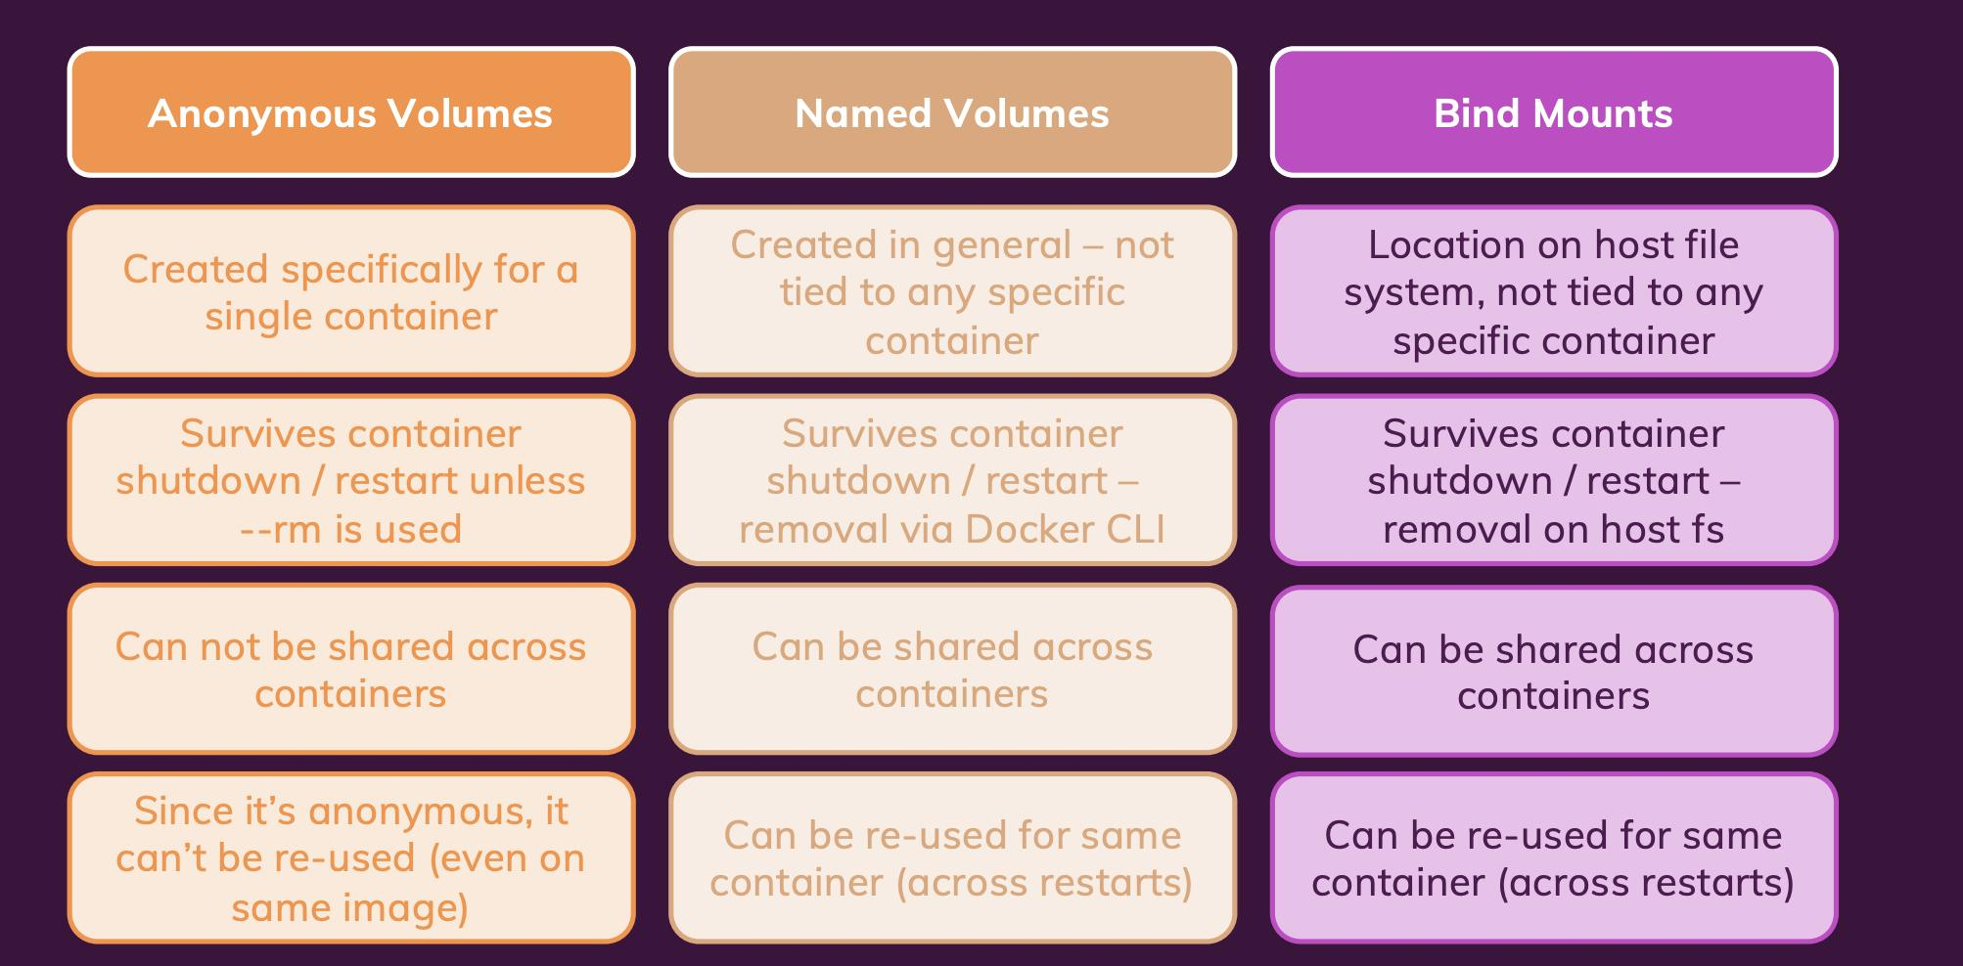

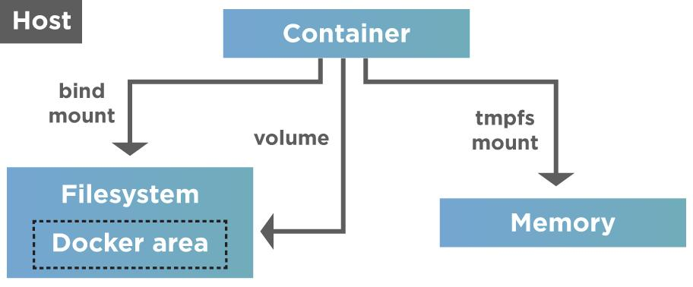

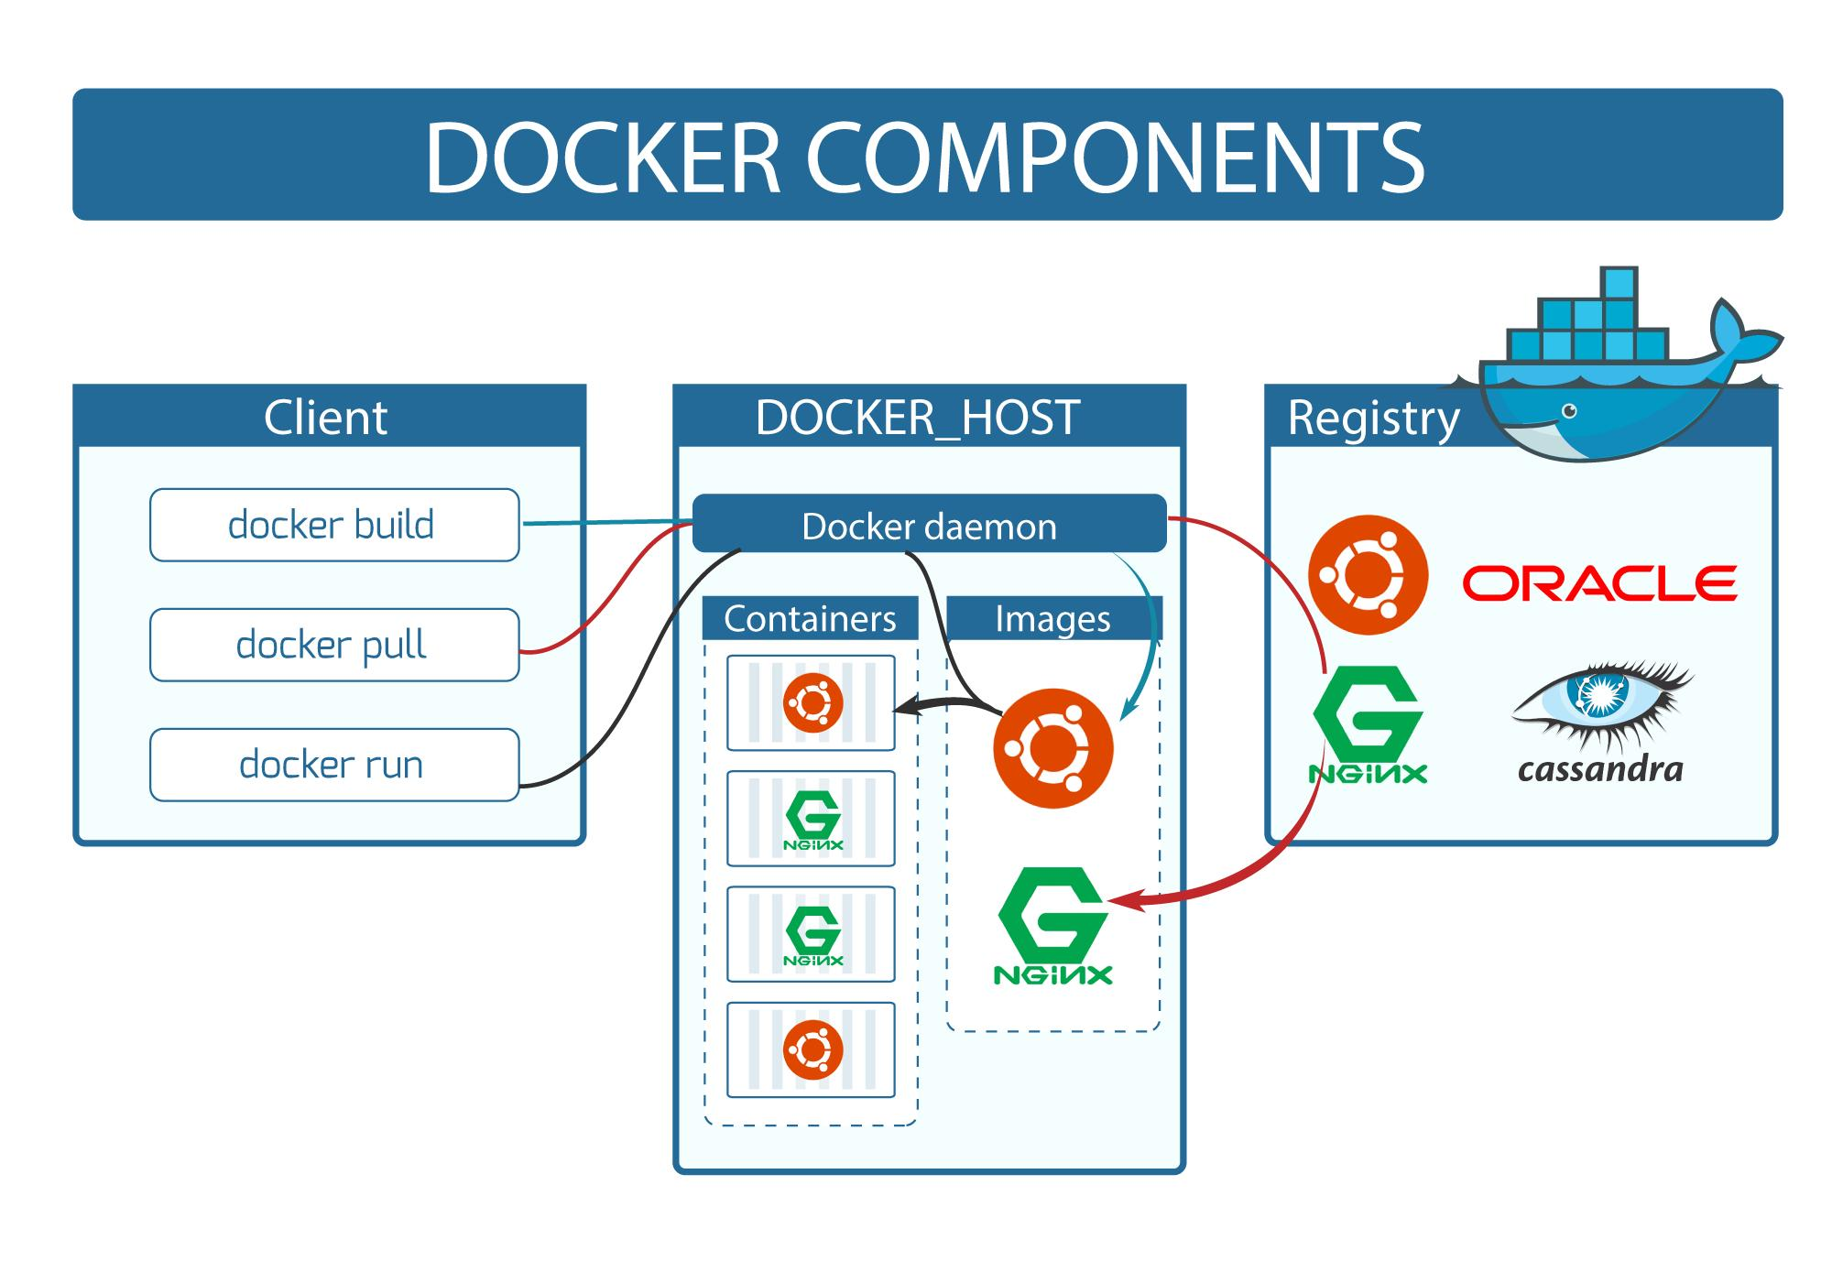

30. Compare Docker images, containers, and volumes with a practical scenario (Expanded Deep Explanation)
Introduction to Core Components
- Docker images, containers, and volumes together form the foundation of containerized application development and deployment workflows.
- Each component has a specific role that contributes to application execution, storage management, and environment consistency.
- Understanding their interaction helps developers design scalable, efficient, and maintainable container-based architectures effectively.
- These components collectively support modern DevOps practices such as continuous integration and continuous deployment pipelines.

Docker Images in Detail
- Docker images are immutable, read-only templates that contain application code, dependencies, and runtime configurations required.
- Images are built using Dockerfiles and follow a layered architecture which improves storage efficiency and reusability.
- Developers can version images using tags, enabling multiple application versions to coexist within repositories effectively.
- Images act as the blueprint for creating containers, ensuring consistent behavior across all execution environments.

Docker Containers in Detail
- Containers are runtime instances of Docker images that execute applications in isolated environments efficiently.
- They include all necessary libraries and configurations required to run applications independently from host systems.
- Containers are lightweight because they share the host operating system kernel instead of using full virtualization.
- Developers can dynamically manage containers by starting, stopping, restarting, and removing them as needed.

Docker Volumes in Detail
- Docker volumes are used for persistent storage, allowing data to survive container deletion and recreation processes.
- They are managed by Docker and stored outside the container filesystem to ensure data durability and reliability.
- Volumes can be shared between multiple containers, enabling data exchange in microservices-based architectures efficiently.
- They improve performance and security compared to bind mounts by providing controlled access to stored data.

Functional Differences
- Images define application structure, containers execute applications, and volumes store persistent data independently.
- Images are static and cannot be modified, whereas containers are dynamic and can change during runtime operations.
- Volumes exist independently of containers and retain data even when containers are removed or recreated.
- Each component serves a distinct purpose, ensuring separation of concerns in containerized application development workflows.

Practical Scenario Explanation
- Consider a web application deployed using Docker, where an image contains application code and dependencies required.
- A container runs the application server using that image and handles incoming user requests efficiently.
- A volume is attached to store user data or database information, ensuring persistence even after container restarts.
- This architecture ensures scalability, reliability, and efficient data management across production environments effectively.

Advantages of Combined Usage
- Combining images, containers, and volumes improves modularity and scalability in application design significantly.
- It allows independent updates of application code, execution environment, and data storage systems efficiently.
- This approach enhances flexibility and simplifies deployment across multiple environments such as cloud and on-premise systems.
- It supports microservices architecture, enabling independent scaling and management of application components effectively.

Importance in Real-world Applications
- These components are essential for building robust, scalable, and portable applications in modern software development environments.
- They enable developers to maintain consistency across development, testing, and production stages effectively.
- Organizations rely on these concepts for efficient DevOps workflows and automated deployment pipelines successfully.
- Mastering these components is crucial for working with container orchestration tools like Kubernetes effectively.

Docker Components Relationship Diagram

